Symplicity Experiential Learning Application – Student Instructions for Internship:
- Go to https://una-csm.symplicity.com. Log in to your Symplicity account using your UNA Portal username and password.
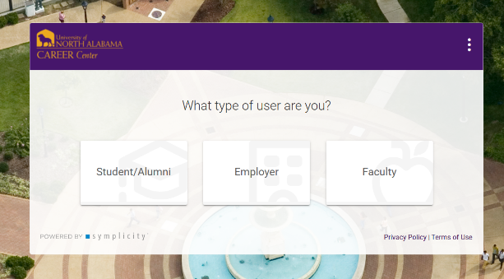
- Once logged in, click on the Experiential Learning tab.
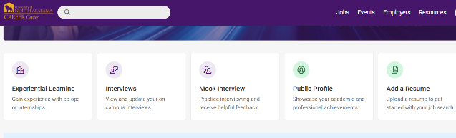
- From here, you will have the opportunity to create new experiential learning logs or review existing logs. To begin, click Add New. Fill in as much information as possible on your EL Application. Make sure to fill in all required fields. Make sure to pay close attention to the small print.
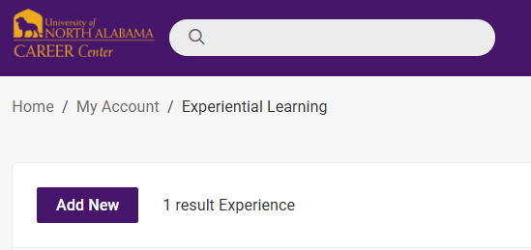
- Select the Experiential Learning Type. It is very important that you select the correct Experiential Learning Type. If you have questions about your EL Type, please check with your Instructor.
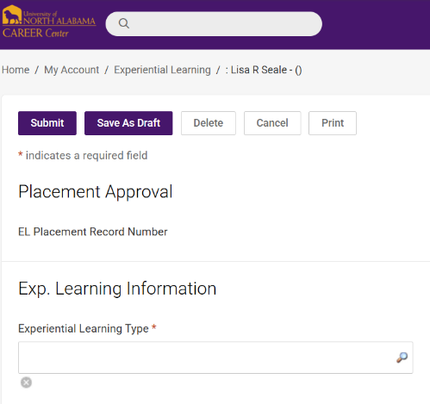

- Fill in the Employer information fields and the Job Title field.
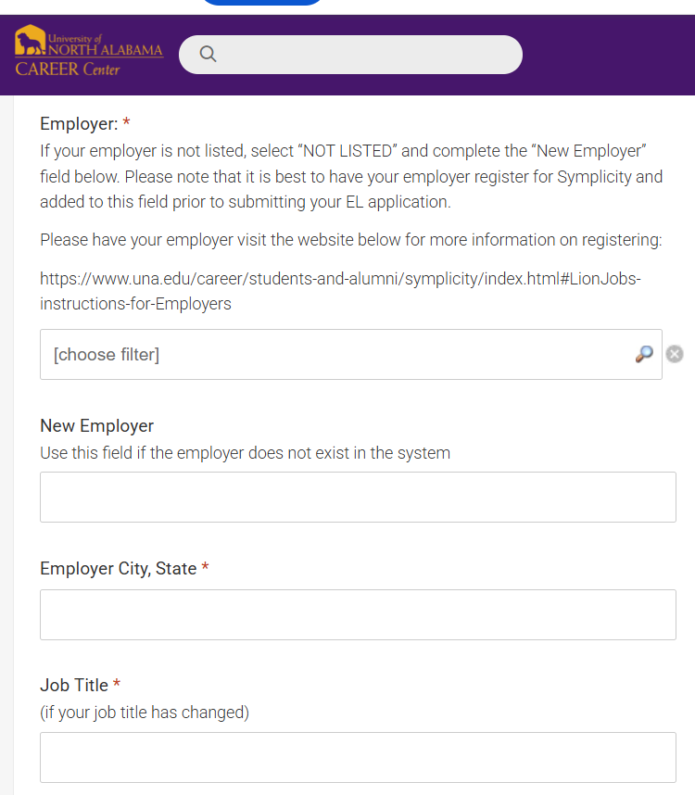
- Since you are logging your Experiential Learning experience for a class, be sure to fill out the Related Academic Information (Subject, Instructor Name, Instructor Email Address, Class Number, Catalog Number, Section, Class Number, and Credits). It is okay to leave the Grade field blank.
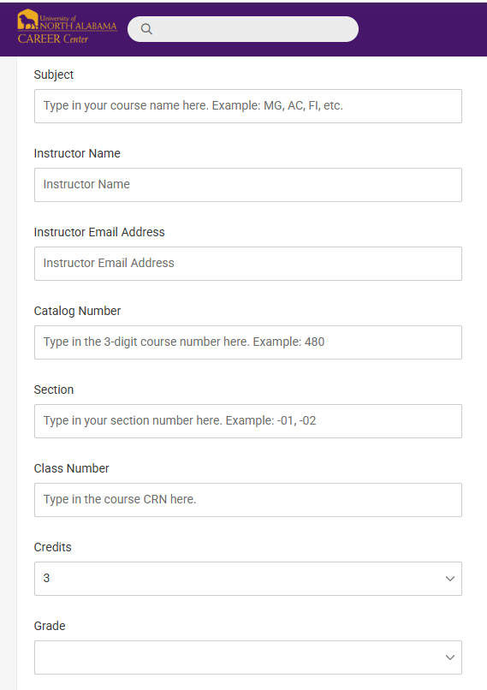

- Select the Work Term. It is very important that you select the correct work term.
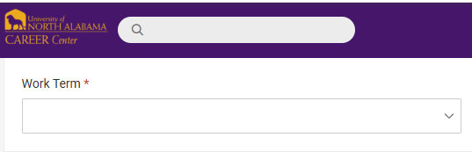
- Answer the following question and select the Start Date (first day of classes for the semester), End Date (last day of class or study day), and the Enroll Date (date you enrolled in the University) if applicable.
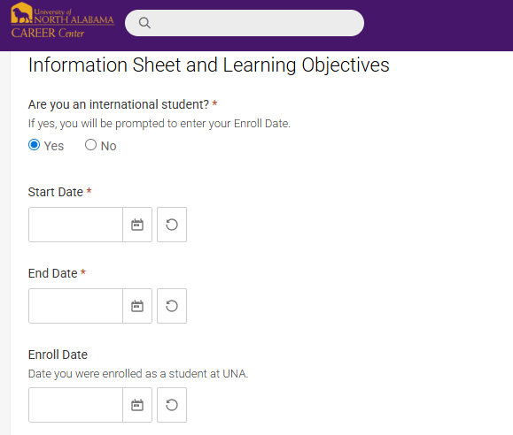
- Complete the fields listed below to the best of your knowledge.
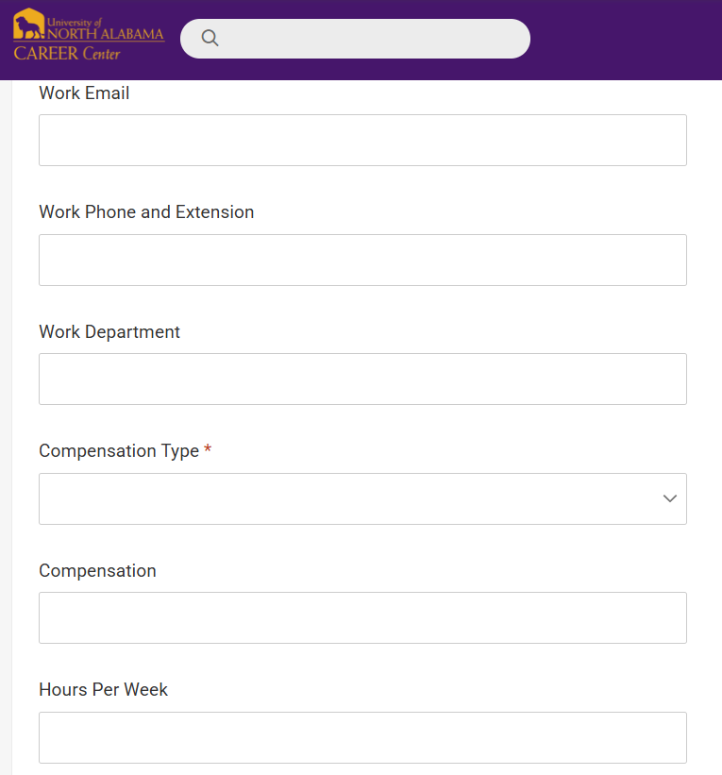
- Add your Supervisor’s information. Make sure that you enter the correct email address for your Supervisor. If your Supervisor’s email address changes during the semester, please edit and update your Supervisor’s email address in your EL Application as soon as possible.
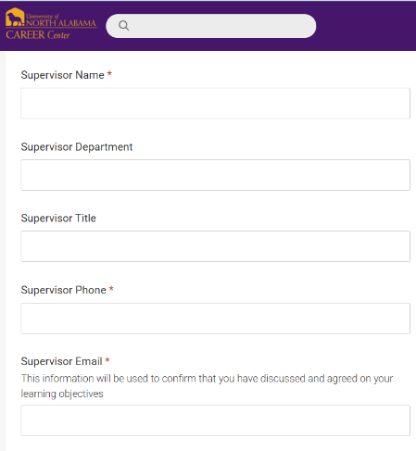
- Complete the following questions. Reference your internship application when completing your job description. Please put N/A if you are not currently experiencing any problems. Be as detailed as possible when entering your work schedule.
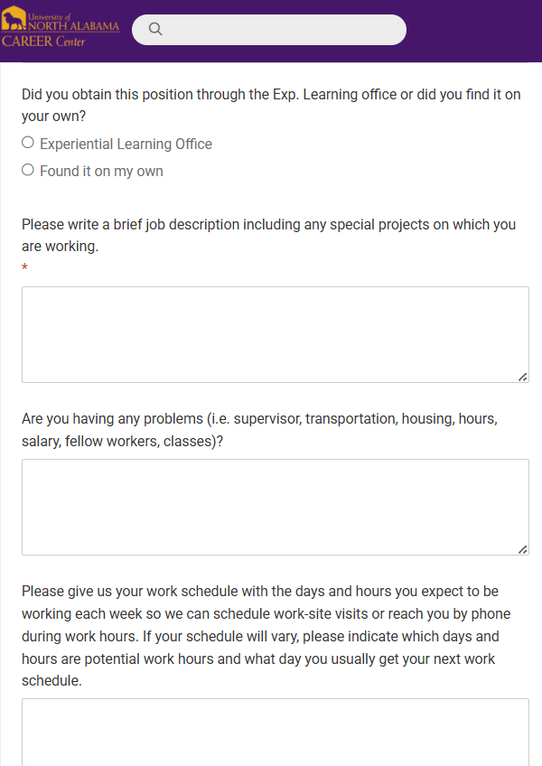
- Please select all of the competencies that you would like to work on this term.
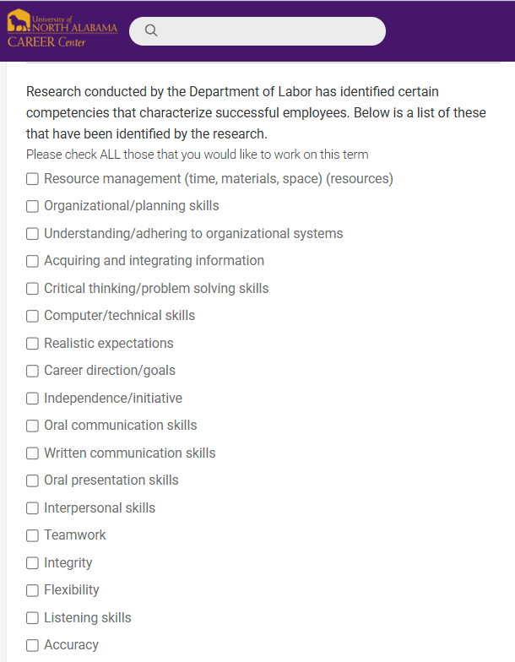
- Take a moment and think about what you would like to learn from this internship experience. Please enter 1-3 Learning Objectives. Complete the Task/Strategies field and the Evaluation field.
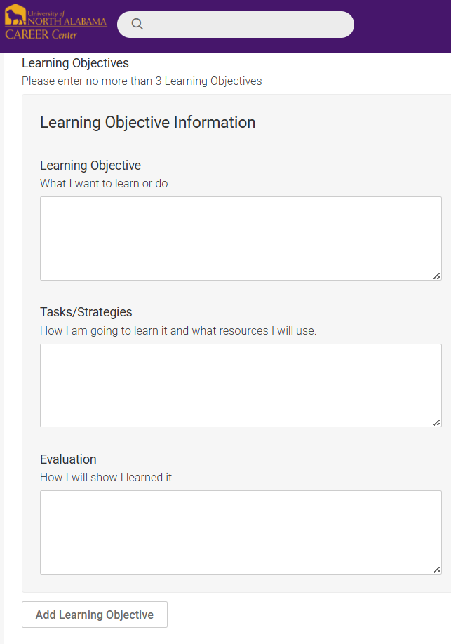
- Upload and attach required documents such as MOU forms and Offer Letters here.
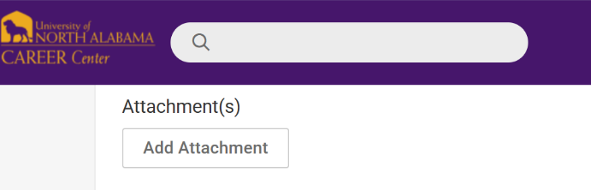
- Sign your name in the Student Agreement Signature field.
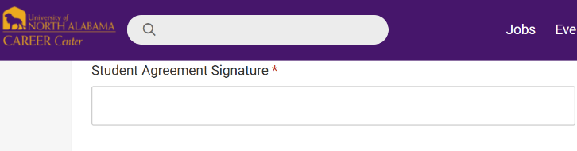
- You can save your data and come back to work on it later by clicking Save As Draft. Once you complete your EL Application, click Submit. Once you click Submit, your EL Application will go to the appropriate Internship Approvers for review. Please note that you will not be able to track your hours until your placement data is approved.
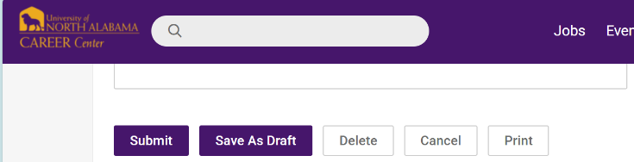

Tracking your internship hours once your placement data is approved:
- Go to Symplicity and click on the Experiential Learning tab.
- Click on Track Hours.
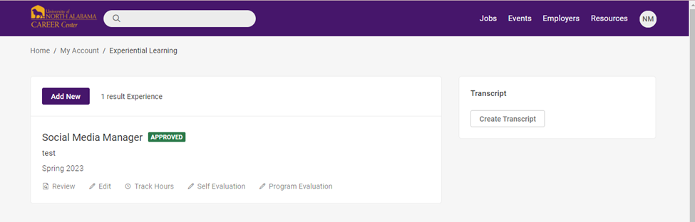
- From here you can log how many hours you worked during a specific time period and list any responsibilities you had. To do so, click Add Hours and fill in the required fields. Click Submit when finished. You can make edits to hour logs if needed. Please check with your Instructor about specific requirements for tracking your hours.
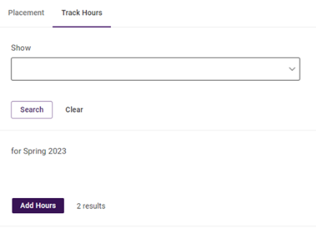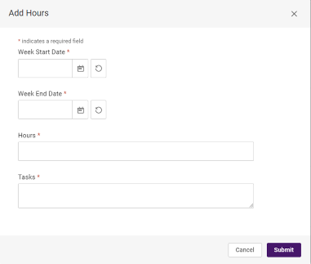

Evaluations:
- Since you are logging your Experiential Learning experience for a class, you will need to complete evaluations at the end of the term. You can access the evaluations by clicking on either Self Evaluation or Program Evaluation. Make sure that you choose the correct placement type when completing your evaluations.
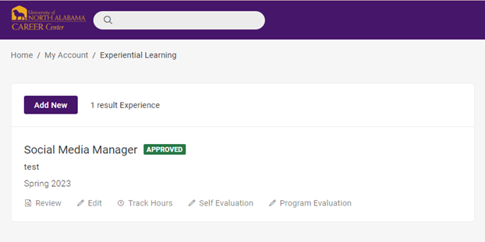
- Your Supervisor/Employer will need to complete the Employer Final Evaluation at the end of the term. It is very important that you enter the correct email address for your Supervisor when creating your Experiential Learning Application. If your Supervisor’s email address changes, please edit your Supervisor’s email address in your EL Application. Your Supervisor should receive 3 evaluation email reminders from Symplicity before the semester ends. If your Supervisor does not receive an email from Symplicity, please let the Experiential Learning Career Coach or another UNA Career Center staff member know as soon as possible. Please email and request that a final evaluation link be sent to your Supervisor. Please provide your Supervisor’s name and email address in the email.

Additional Information:
- If you have questions about Symplicity or need help with your EL application, please make a General Assistance appointment with the Experiential Learning Career Coach or another UNA Career Center staff member. Find the link to the UNA Career Center’s booking page below:
https://unacareer.youcanbook.me/
- It is best to have your Employer/Supervisor register for Symplicity and added to the Employer field on your EL application prior to submitting your EL application for approval. If your Employer/Supervisor needs more information on creating a Symplicity account, they can find more information here:
https://una.edu/career/students-and-alumni/symplicity/index.html#LionJobs-instructions-for-Employers
- Find a link to the MOU form below:
https://www.una.edu/career/experiential-learning/docs/una-experential-learning-program-memorandum.pdf#Experiential%20Learning%20Application
- You can create transcripts for your Experiential Learning experiences. You can choose which experiences you would like to include. All you need to do is click Create Transcript and select the experiences of your choosing and click Submit.

