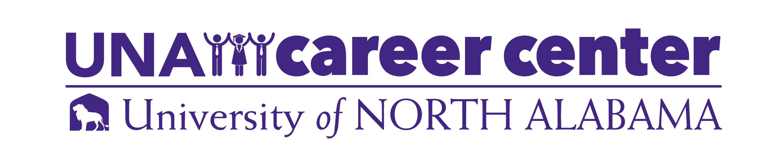
Table of Contents

Mission Statement and Services 2
Professionalism…………..………………………………………………………………………..3
Career Action Plan……………………………………………………………………………….. .4
LionJobs Instructions 5
Career Exploration .6
Information Interviewing 14-15
Gain Experience 16
Graduate School 17
Job Search 18
Networking 19-20
Social Presence 21-22
Creating a Cover Letter 23-24
Résumé Development 25-42
Action Verbs 43
Professional References 44
Interview Preparation 46
Attire 53
Dining Etiquette 54
Thank You Notes 55
Life After College 56
Résumé Examples 25-42


UNA Career Center
256-765-4276
careercenter@una.edu
una.edu/career
Collier Library, 2nd Floor

“Resources for Your Future”
The UNA Career Center is committed to empowering students and alumni to engage in all phases of career development. In support of this mission, the Career Center serves as the primary resource on campus for career related information; providing resources, services and programs to facilitate successful career development as it relates to students, alumni, faculty and employers.

Student success in career development is demonstrated when students exhibit confidence in choosing and pursuing their path.

Career Center services include but are not limited to:
- Assisting with major and career choices
- Providing information about the job search process and different occupations
- Maintaining LionJobs database of employment opportunities (on- and off-campus, part-time and full-time, internships and co-ops, paid and unpaid)
- Assisting with résumé and cover letter writing
- Preparing students for interviews, conducting mock-interviews
- Hosting career and graduate school fairs
- Connecting students and alumni for career mentoring

The UNA Career Center embraces the University’s commitment to diversity and is dedicated to supporting students from all backgrounds, cultures, and identities. We are committed to ensuring all experiences and perspectives are respected, recognized, and integrated into career planning and development and encourage all UNA students to engage with us as we continue to grow together as a campus community.

UNA Academic Programs and Majors

COLLEGE OF ARTS, SCIENCES, AND ENGINEERING

COLLEGE OF EDUCATION AND HUMAN SCIENCES

COLLEGE OF BUSINESS AND TECHNOLOGY

ANDERSON COLLEGE OF NURSING AND HEALTH PROFESSIONS

How to Use this Career Guide

This Career Guide is meant to serve as a tool to assist you in your personal career preparation. The job search process requires much individual thought, preparation and decision-making. It is our hope that this guide will provide a starting point for you towards that end.

The UNA Career Center looks forward to working with you as you develop your own personal career plan. We encourage you to stop by our office to utilize the resources and expertise we have to offer.

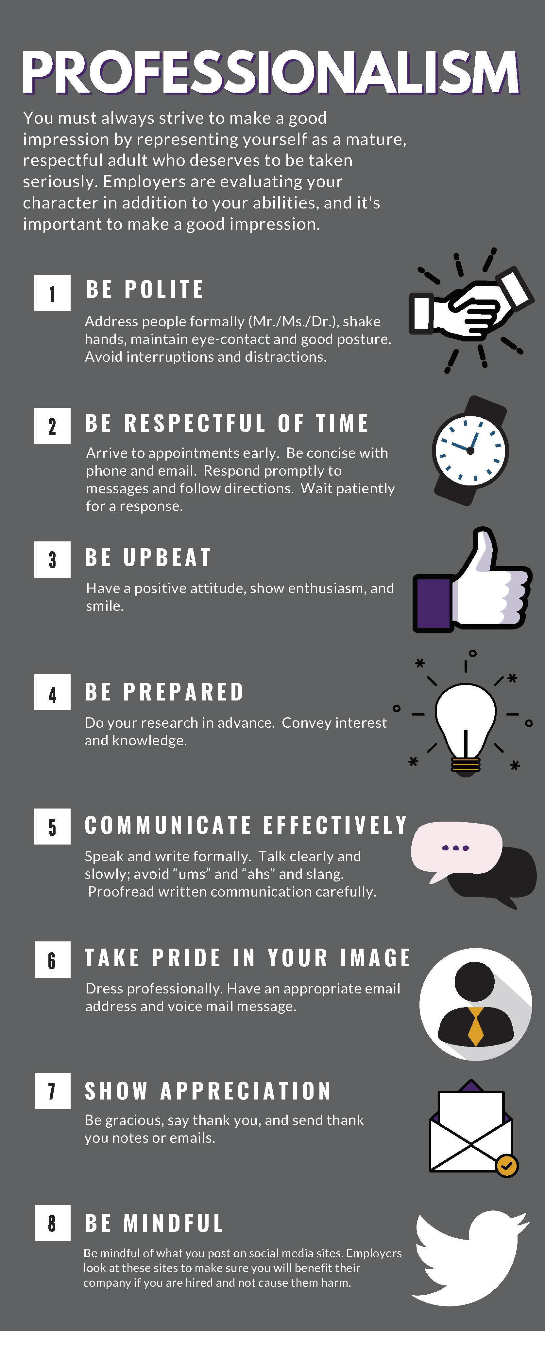
PROFESSIONALISM

As you begin to explore the world of work, realize that the workforce world has different rules, procedures, and behaviors than are common in the school environment.

It is important to be aware of these differences in all phases of career exploration and development and especially during the job search phase.

CAREER ACTION PLAN

Preparing for your first career position begins as you start your college career. Follow this checklist each year to be sure you are preparing for your career both inside and outside the classroom.

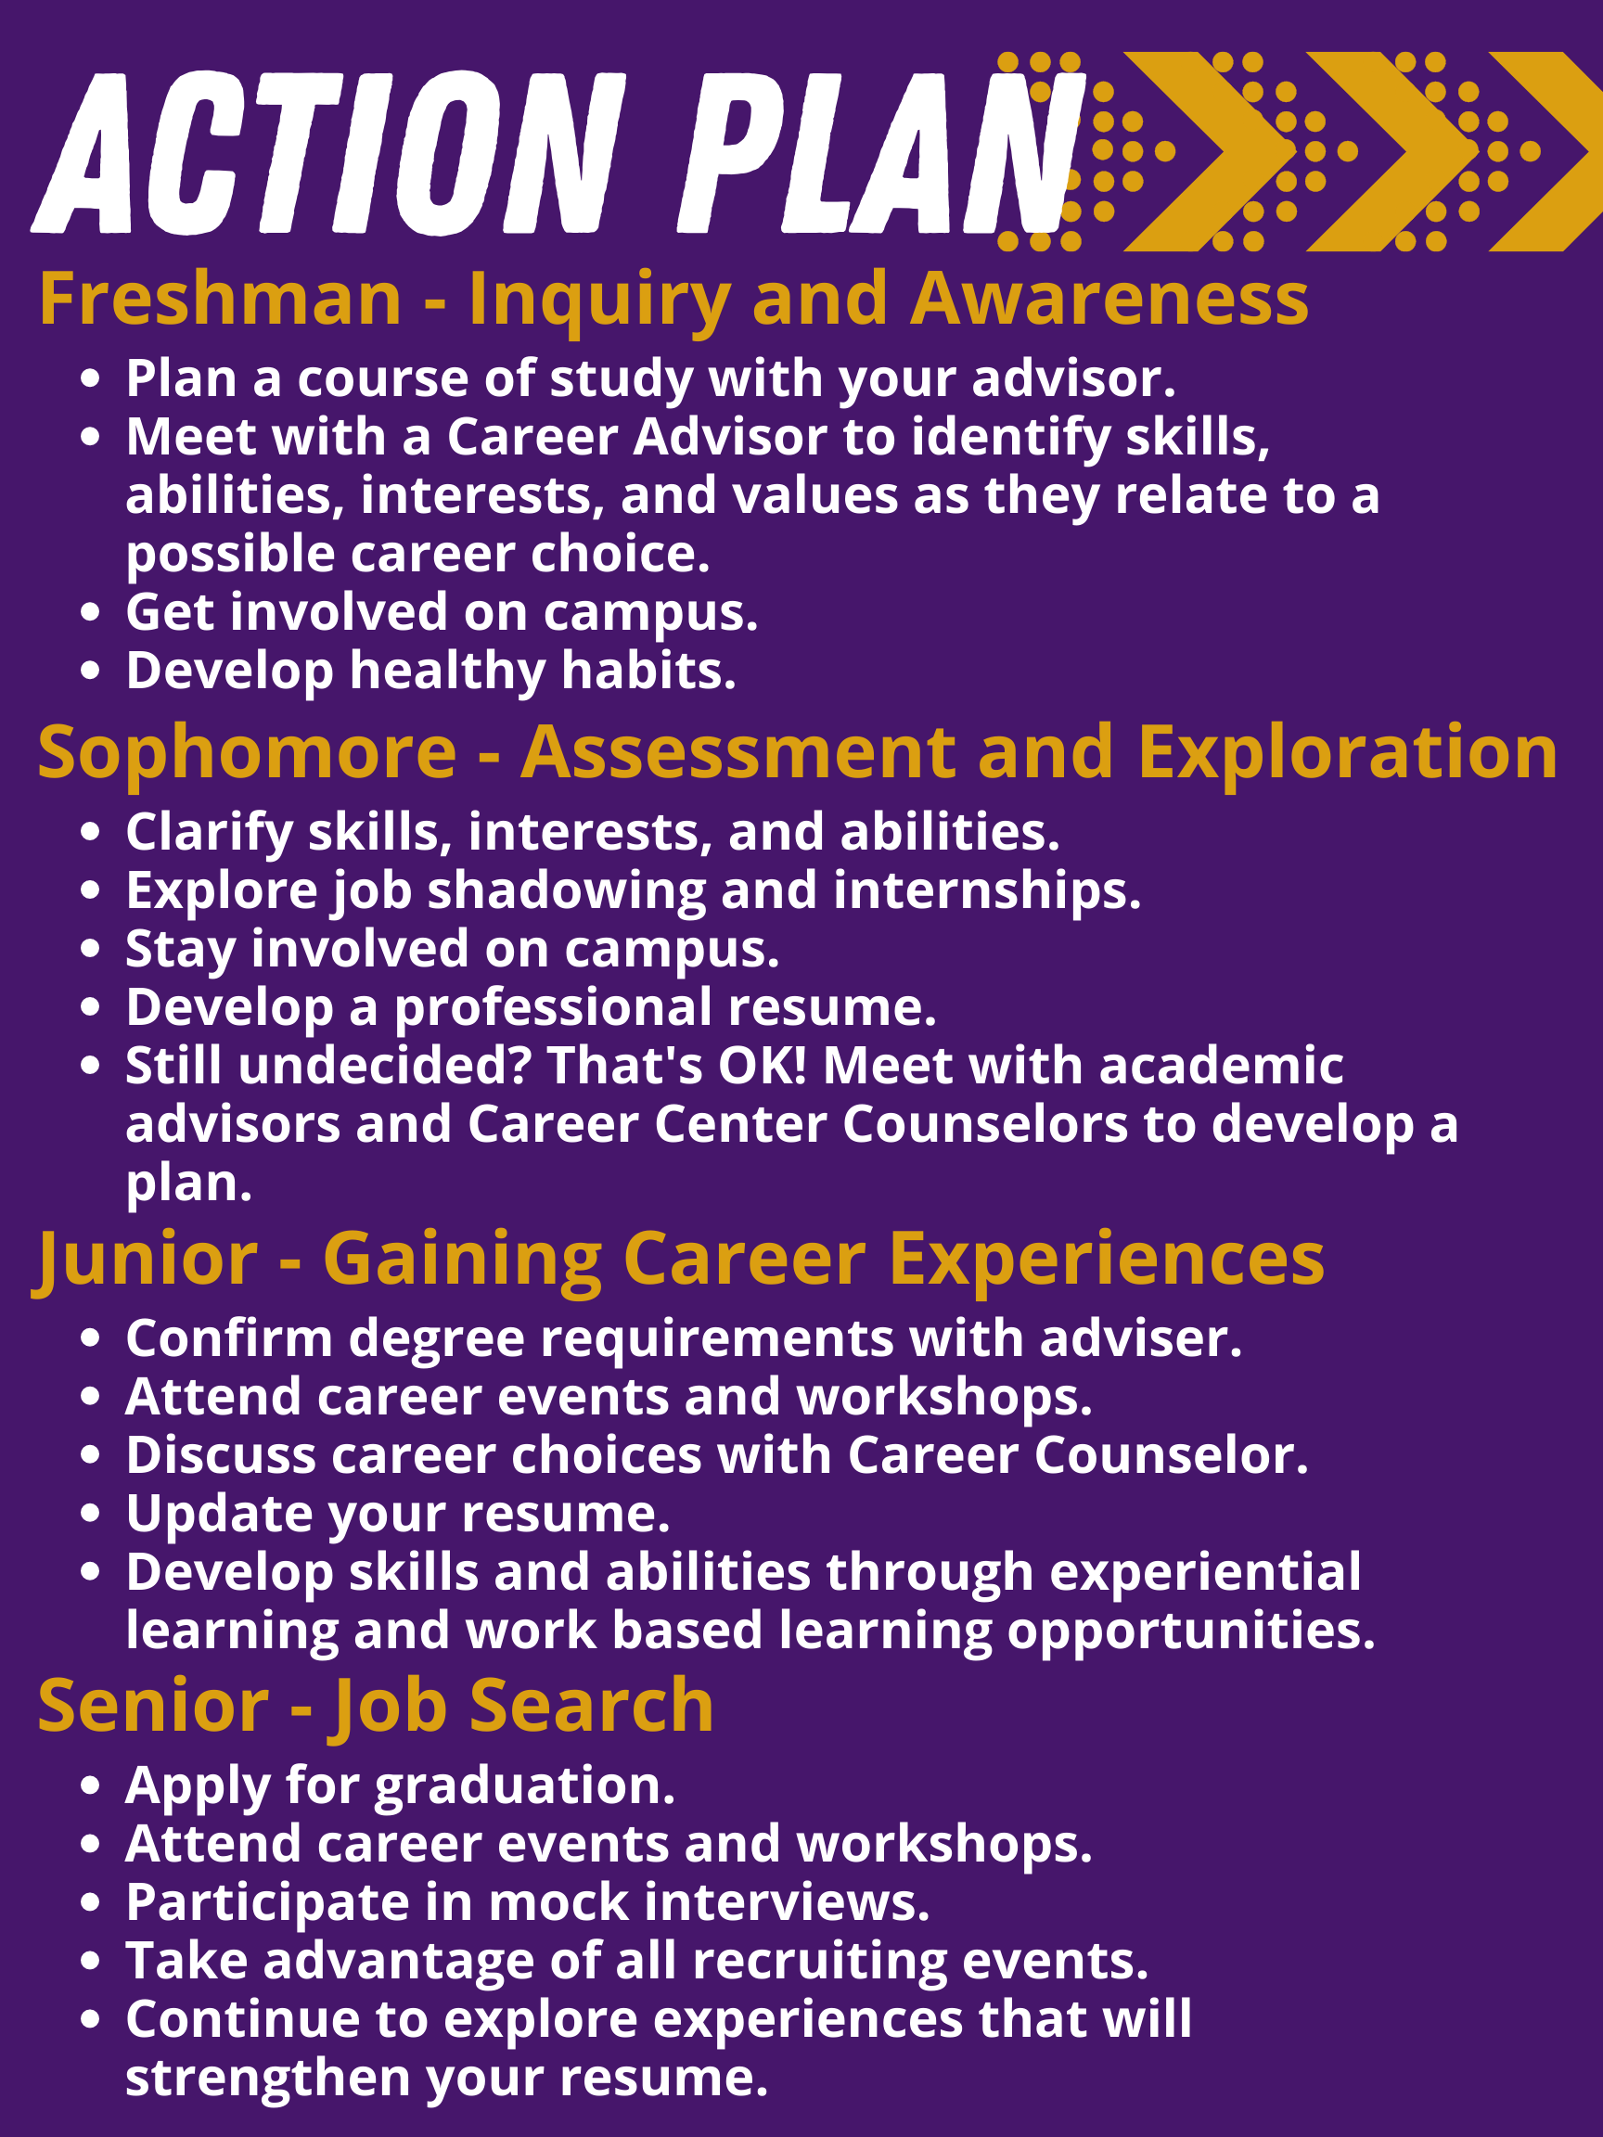

Graduate/Professional School Students and Alumni
- Make sure your LionJobs Account is updated at csm-una.symplicity.com
- Meet with a Career Counselor to discuss career interests and ways to market your experiences
- Clarify work interests and associate them with educational and career opportunities by utilizing self-assessments and other information resources
- Continue to update and revise your résumé
- Network with employers through LionJobs, On-Campus Recruiting, and Career Fairs
- Report employment status to the Career Center via the First Destination Survey and Career Outcomes in LionJobs

LIONJOBS INSTRUCTIONS

https://una-csm.symplicity.com/

Uploading a Résumé, Cover Letter, or Other Documents:
- First, view sample résumés. We recommend you use Microsoft Word to create your resume.
- Log in to your LionJobs account using your Portal login information. Click the DOCUMENTS tab in the left column, then MY DOCUMENTS.
- Click ADD NEW. LABEL your document, then choose type.
- Browse to locate and upload your document. Once it has uploaded, click SUBMIT.
- Your document will be sent to the Career Center for review and approval BEFORE you can apply for a job.

Resumes and Cover Letters will be reviewed to ensure they have up-loaded correctly, and for spelling/format errors. Please allow 24 hours for review.
- You will receive an email with comments and instructions.
  - Make any suggested changes and re-submit.

When your document is approved, you will be able to apply for jobs.

To search for jobs:
- Click the JOBS tab, then Search/Advanced Search.
- Click Position Type, and choose the type of employment you are seeking. (For On-Campus jobs, choose Student Employment).
- Scroll down to view the list of positions. Click on the job title of the position you wish to review.
- Follow the instructions to apply for the job.

CAREER EXPLORATION

Discover Your Options

Research is an essential first step on the path to a successful and rewarding career. You cannot choose a career path until you know about the different types of careers available. The perfect job is probably out there waiting for you, but you might not even know that it exists! Even if you think you know exactly what you want to do, spend some time learning about related careers and keep your options open.

Online Resources

The Occupational Outlook Handbook is a nationally recognized source of career information, designed to provide valuable assistance to individuals making decisions about their future work lives. The Handbook describes hundreds of jobs in terms of the training and education needed, earnings, expected job prospects, what workers do on the job, working conditions, and related occupations.

The O*NET program is the nation's primary source of occupational information. It is an interactive database that contains details on hundreds of standardized and occupation-specific descriptors. It also offers valuable assessment instruments for individuals looking to find or change careers.

Career One Stop is sponsored by the U.S. Department of Labor and offers career resources and workforce information to foster talent development in a global economy. It includes America’s Career InfoNet, which helps individuals explore career opportunities to make informed employment and education choices, and America’s Service Locator, which connects individuals to employment and training opportunities available at local One-Stop Career Centers.

The AlabamaWorks Career SUCCESS Guides will help you learn more about upcoming high-demand careers and their salary ranges, the steps you need to take to reach your career goals, and the resources available to help you get there. There are sixteen guides, one for each career cluster.

Other Resources for Career Exploration

Career Fairs –Attend these types of recruiting events in your freshman and sophomore years to explore your options. Ask lots of questions; learn what employers are in your area, what types of positions are in demand, and what credentials are expected of applicants. Ask what the position entails and what other opportunities exist in that field.

Use Your Network –Talk with people about what they do for a living, what they like and dislike about their work, and what they studied in school. In addition to offering insight in the exploration phase, these same individuals can be helpful when you’re ready to begin applying for jobs. Don’t forget to talk with members of your family, friends, neighbors, professors, and advisors. Most people love talking about themselves and will be glad to share their experiences with you!

Job Shadowing – Observing people in their work setting can be the best way to learn what is truly involved with their occupation. Arrange to spend a day or an afternoon observing someone in a line of work that interests you. Being in the environment and witnessing the day-to-day happenings and job responsibilities will offer realistic insight that is difficult to gain in any other manner.

Information Interviewing - Information interviewing is a technique used to explore and research occupations and organizations. It has several benefits, including:
- Discovering first-hand knowledge and perspective about an occupation or job.
- Providing access to the “hidden” job market. Only 20% of all job openings are advertised! Direct contact and networking are essential to finding out about unadvertised job openings. Information interviewing is not a job interview, but it will establish your interest and can be a helpful first step in eliciting information about a prospective employer.
- Improving your self-confidence and interviewing skills.

The steps below explain how to set-up and conduct an information interview. The more prepared you are, the more you will get out of it!

STEP 1: Identify Occupations, Job Titles, or Potential Employers of Interest –Look to the following resources: UNA Career Center, professional associations related to a particular industry or occupation, specific organizations’ websites, employees of the targeted organizations, career field videos at CandidCareer, online employer reviews/ratings (e.g. Glassdoor, Great Place to Work, and Indeed), and the local Chamber of Commerce.

STEP 2: Identify Potential Contacts –This includes family, friends, instructors, employer directories, the Career Center employer listings, and other networking contacts within the community. You may have to contact the organization directly to identify someone you can interview. Familiarize yourself with professional titles for the types of people you’re trying to contact. As an example, if you are interested in a marketing position, you might contact a particular organization and ask them for the name of the Director of the Marketing Department. Also, note that some organizations have recruiters or talent acquisition teams which can provide information.

STEP 3: Schedule the Interview –Send an email or call to arrange an appointment with the target individual. Be clear that you’re not looking for a job currently and only trying to obtain information. You might begin your conversation like this:

Student: “Hello, Ms. Smith, my name is _________________ and I am a University of North Alabama student. I am very interested in marketing and I am trying to learn as much as I can about careers in marketing. I have read a lot about the subject, but I really feel it might help to talk to someone who works in the field. If you have the time, I would appreciate meeting with you to discuss this occupation. The interview would only take approximately 20-30 minutes to complete. My schedule is flexible and I can meet with you at your convenience.”

STEP 4: Prepare Your Questions –Based on your goals and the results of your research of the area, prepare your questions for the interview. Try to make them open-ended questions, not questions with simple “yes” or “no” answers. The suggestions below may give you some ideas:

- What is a typical day in the life of a ________?
- How did you get interested in this occupation?
- What do you like and dislike about your occupation?
- What is a typical career path in this occupation?
- What kind of academic/training preparation do you recommend for this occupation?
- What is the projected growth for this occupation?
- What skills should I be developing?
- Would you recommend participating in any particular clubs or organizations?
- What is the organizational structure and where does your position fit in the organization?
- Is there someone else you can suggest for me to contact?
- If you were going to hire a new entry level person, what would a highly qualified candidate be like?
- What are the major challenges/problems that your organization is facing in the upcoming year?

STEP 5: Conducting the Interview –Dress in business attire and arrive early for the interview. Establishing a positive first impression is vital. Be confident, smile, and take notes. Employers tend to remember people who exhibit self-confidence and a positive attitude. At the end of the interview, express your appreciation for their time. Send a thank you note to the contact following the interview.

STEP 6: Evaluate –Based on the information gained, ask yourself the following questions:
- What did I learn about this occupation?
- What did I learn from the experience in general?
- What did I like about the job? What didn’t I like about the job?
- Am I still interested in this career?
- Am I willing to do what is necessary to be successful in this career?
- Did I learn of any related careers that I should explore?
- How can I make the next information interview more successful?

Gain Experience through Experiential Learning

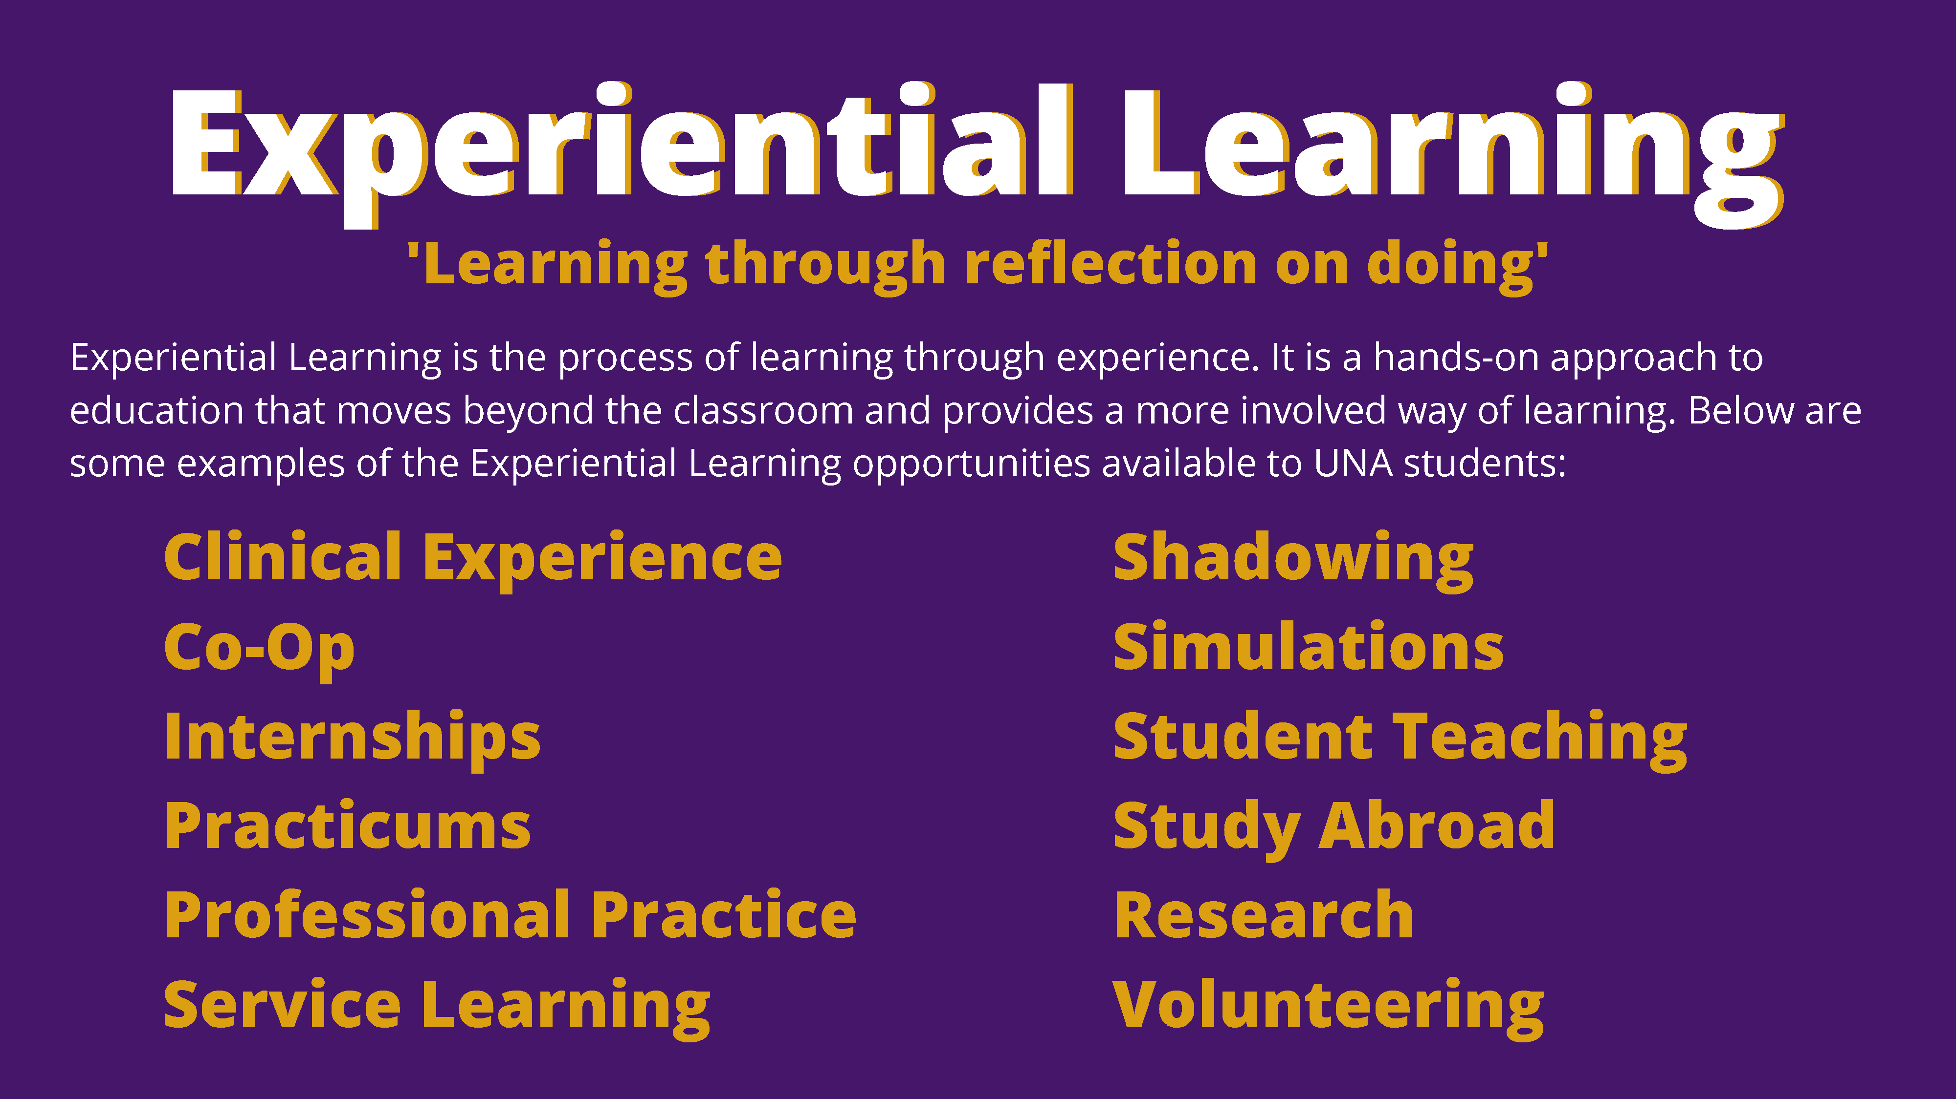

After you’ve identified careers of interest, obtain relevant experience. Experiential learning is a process through which students develop knowledge, skills, and values from direct experiences outside a traditional academic setting. It is gained through work-related activities that help explore and clarify career interests and foster personal and professional growth while developing professional contacts.

Service Learning – Service-learning gives students the opportunity to integrate academic experiences with intentional and thoughtfully organized service experiences, for students to gain greater context with what they are learning in the classroom. Students who participate in service-learning can connect classroom learning to real world problems and issues, as well as network with community leaders, giving them greater experience for when they try to get internships, co-ops and full-time employment.

Internships – Internships offer a hands-on opportunity to learn practical skills in the work environment rather than in a classroom. They give students the chance to put theory into practice and to see how the two work together. An internship should be a carefully monitored and structured experience that has intentional learning goals and outcomes. An internship is usually a semester in length and coincides with the school term. Students who participate in internships:
- Become self-managed learners
- Learn problem solving skills and improve communication skills
- Are better prepared and viewed as better candidates for employment
- Receive more job offers and can be selective
- Earn higher salaries

The Career Center posts all known internship opportunities on LionJobs. Students are responsible for securing their own internships, as the Career Center does not place interns. Once hired, students work with their college and then the Career Center to determine if academic credit will be approved and to complete the process.

Externships – An externship is a “shadowing” arrangement as opposed to performing work tasks, where students can spend anywhere from a single day to a few weeks gaining exposure to an organization. Externships can provide students with the opportunity to determine if they like a specific job, organization, or work environment; they require minimal investment of time, provide specific experiences to enhance job marketability, and may provide an avenue for future internship opportunities or employment. Students typically set up this arrangement for themselves.

Co-ops – A co-op is even more structured than an internship. It usually requires students to work full-time for a semester and then attend classes for a semester for a 3-rotation work period. A student may also work part time and attend school part time with the same 3-rotation work period. Students retain full-time student status while participating in the co-op, even during the semesters they are not enrolled in classes. Students acquire increasing levels of responsibility and use their job knowledge and classroom learning to make meaningful contributions to the employer.

Part-time and Summer Employment –Take advantage of your summers and free time in college to explore the world of work. It’s tempting to babysit or mow lawns to make some extra money, but challenge yourself by seeking employment that is more in line with your career interests. Employment related to your career interests will provide valuable experiences, enhance your qualifications for future employment, and provide beneficial networks which may be utilized for professional references or prospective employment opportunities.

Volunteer –Volunteering in the community can be an excellent learning experience. It also establishes genuine interest, as others recognize that you aren’t likely to do something for free unless you are truly committed.

Extra-Curricular Activities – Participating in social or philanthropic student organizations on campus is an excellent way to get real world experience while in college. Join a student group related to your major or interest area and take an active role. Attend meetings and events regularly, and work toward assuming a position of leadership.

Graduate School

If you’re considering continuing on to graduate school, first and foremost, you must determine WHY! Choosing to attend graduate school as a means of delaying the job search is not a wise move, even in poor economic times. Ask yourself:
- Is a professional graduate degree needed for my professional career (medical/law/dental school, etc.)?
- Will graduate education assist me in pursuing my personal career goals? (i.e. MBA)

Applying to Graduate Schools – Decide where you would like to attend graduate school based upon the type of program offered, geographic location, admissions requirements, etc. Begin reviewing application criteria during your junior year. Deadlines will vary significantly depending on the institution to which you apply. Contact programs about visiting, and make trips if possible. (Be sure to brush up on your Interviewing Skills.)

Admissions criteria are one of the main factors you must take into consideration when applying to graduate and professional schools. Entrance criteria and standards vary by institution and are dependent upon the academic discipline, selectivity of the institution, and number of seats available in the program.

Criteria for admission will typically include the following:

- Grade Point Average (GPA)
- Standardized test scores (GRE, MAT, LSAT, MCAT, or GMAT score)
- Personal Statement/Statement of Purpose
Meet with current faculty members to discuss your statement and possible programs. Ask for letters of recommendation.
- Experience or Undergraduate Research
- Completion of Course Prerequisites
- Letters of Recommendation
- Admission Essays
- Résumé or CV

To How Many Schools Should You Apply?
A common recommendation is to apply to five or six schools, reflecting the following categories:
- One program that is extremely desirable with very competitive admissions standards
- Three programs that are realistic for you in terms of admission standards and that also meet your criteria
- Two programs you are confident in being admitted to that meet your criteria
Some students choose to apply to 10 or more graduate and professional schools; however, keep in mind that this can become costly in terms of time and money.

When Should You Start Submitting Applications?
- Be sure to contact each school well in advance to determine graduate application deadline dates. Most deadlines fall between December and March but each program will have a specific deadline.
- Generally, the more competitive the program, the earlier you need to submit all pertinent application materials.

What Financial Aid and Assistance Are Available to Graduate Students?
Contact institutions directly to learn about financial assistance. The aid package will incorporate a combination of:
- Work programs (assistantships, institutional funding, and other part-time jobs on campus)
- Monetary awards (grants, fellowships, and scholarships)
- Loans (subsidized and unsubsidized). **Make sure you understand the differences in loans and your responsibility to repay them. **

JOB SEARCH

There is no quick, easy way to find a job. You should expect to put a considerable amount of time into identifying opportunities. Research your field of interest thoroughly and develop a list of all potential employers. Consider all employment sectors including businesses, government, and nonprofit organizations. Once you’ve compiled that list, individually research each employer and familiarize yourself with the procedures for applying for positions.

LionJobs – LionJobs is an online database that lists full- and part-time jobs, internships, and unpaid opportunities available to UNA students and graduates. New positions are added daily, so be sure to check the site frequently. Log in to your LionJobs account here.

Other Online Sources – Don’t overlook the following types of websites:
- Chamber of Commerce websites
- Professional association websites
- Websites of individual companies
- Local, state, and federal agency websites
(e.g., City of Florence, Alabama State Personnel Department, USAJobs)
- Employment websites like Indeed and CareerBuilder

Career Fairs – Many employers who attend recruiting events are hiring! Take advantage of the fact that these employers are all under one roof. Dress professionally and bring copies of your résumé. Find out in advance what companies will be represented and research those that are of interest to you. Some larger companies host their own job fairs. Note that employers hire a variety of majors. For example, almost every corporation has someone responsible for marketing, accounting, and human resources.

Network – Make sure that the people in your network are aware that you are looking for a job. In addition to any professional contacts you’ve made, remember to talk with your family, friends, neighbors, professors, and advisors.

Job Search Etiquette – Etiquette becomes especially important when you are looking for a job. You must convince potential employers that you are able to conduct yourself in a professional manner on the telephone, in written communication, and in person. Put effort into your application materials. Once submitted, be patient waiting for a response. If you call the organization, be polite, not pushy. If you are offered an interview, prepare thoroughly and convey to the interviewer that you are a serious candidate and can meet and exceed expectations. Try to keep your excitement from coming across as arrogance. Strive to appear confident without being obnoxious.

Using Email – You must always be professional when communicating with prospective employers. Put just as much time and effort into composing an email as you would writing your résumé or cover letter, and follow these guidelines:
- Proofread carefully for incomplete sentences, punctuation, spelling, and grammatical errors
- In the “Subject” line, write something concise and descriptive
- Consider creating a signature block, complete with your contact information as listed on your résumé
- Be sure your email address is professional (not partygirl@xyz.com)
- Be careful about including flowery quotations or extraneous statements in your signature block
- Internet slang including LOL, Thx, and :) are not acceptable in professional email communication
- Check your email regularly and respond promptly to any employment-related messages
- Read emails thoroughly before responding, and follow all directions
- Don’t write in all UPPERCASE or bold; this is considered SHOUTING at the recipient

Posting your Résumé Online – Many career websites provide job seekers with the option to upload a résumé that will be available to hiring employers. Employers are able to read through all posted résumés and contact the most qualified candidates. In practice, very few people get hired using this approach. If you decide to post your résumé online, remember that these types of résumé banks are essentially open to the public. Also, be respectful of the individuals you’ve listed as references and do not post their information online. If you are contacted by an employer about a position, you can send references separately at that time.

NETWORKING
Networking is key in securing employment and should not be underestimated. When employers have an open position, they first think of whom they know personally that can fill the position. If the employer doesn’t know anyone, he/she will begin asking trusted friends, coworkers, and family members if they know anyone who can fill the position. If that avenue doesn’t bring a prospective employee, the employer will check to see if they have any résumés on file. If they are still unable to select a candidate, the employer will turn to staffing agencies for help. The last resort for most employers is posting an advertisement for the position on job boards.

Many students spend a lot of their time solely focused on job advertisements and not enough time networking with others. Sure, there might be an advertisement posted, but in most cases, the employer already has an idea of whom they wish to hire.

The picture below illustrates the way most employers hire:

Social Presence

Evaluate Your Web Presence – Employers are evaluating your character as well as your abilities, and it’s important to make a good impression. Before beginning your job search, take a minute to consider the following:
- What kind of information might an employer be able to discover about you from the Internet? “Google” yourself and see what results. Consider whether this is information you want made available to a prospective employer.
- Review your profile on social networking sites like Instagram, Twitter, Facebook, or Tik Tok. Photos and certain types of information or messages may work against you as you seek to make a good impression. While you probably think the messages and pictures are funny and innocent, employers might think they are immature, unprofessional, or even arrogant. Most networking sites have detailed privacy options; make sure you understand how these work and restrict access to your friends only. Even if you take this precaution, realize that others may gain access to your profile in any number of ways. Consider untagging yourself from questionable photos and deleting any questionable messages.
- Develop your professional presence using a LinkedIn profile. LinkedIn is a well-respected, professional, online tool for job search.

LinkedIn

LinkedIn is a professional social networking site designed as a marketing and branding tool for jobseekers. You can use LinkedIn to:
  - Learn about trends in specific industries and organizations.
  - Follow industry experts and engage in meaningful conversations with your connections.
  - Search for jobs.
  - Connect with university alumni, classmates, faculty, and staff.
  - Join groups related to your academic and career interests.

Complete your profile –Users with complete profiles are 40 times more likely to receive opportunities through LinkedIn. List all of your experiences, including summer jobs, unpaid internships, volunteer work, and student organizations.

Use your inbox –Networking doesn’t mean reaching out to strangers. The best networks begin with those you know and trust, and then grow based on personal referrals. Start building your LinkedIn network by connecting to friends, relatives, internship colleagues, and professionals you know.

Get personal –Customize your connection requests with a friendly note and, if necessary, a reminder of where you met or what organization you have in common. If a mutual friend is referring you, write a brief intro of who you are and why you’d like to connect. You’ll impress people with your personal touch.

Lend a (virtual) hand –As you build connections and group memberships, think about what you can do to support other people. Comment on a classmate’s status update, forward a job listing that fits the criteria of a friend, or write a recommendation for a summer job.

Update your status often –Networking is not just about who you know; it’s about who knows you. Stay on other people’s radar by posting updates on events you’re attending, projects you’ve completed, and other professional news.
COVER LETTERS

Once you’ve identified positions to apply for, it’s time to prepare your application materials. You should include a cover letter each time you submit your résumé for a position. The cover letter is your opportunity to highlight your skills and qualifications and to explain why those experiences make you a good candidate for the job. Do not just reiterate your résumé. Instead, focus on several key areas and go into detail including what you did and what you learned.
- Always tailor your cover letter to the specific organization and job for which you are applying. Research the organization and include sentences that correspond to the job duties or qualifications from the job description. Employers will know if your cover letter is generic and mass produced.
- When submitting a résumé by email, consider the body of your email as the cover letter. Include your contact information in your email signature.
- When submitting your application by web upload or mail, the cover letter should be typed in the same font as your résumé in business letter format. The heading of your cover letter should match the heading of your résumé. The letter should be 3 or 4 paragraphs and should not exceed one page in length.
Remember, the cover letter is a sample of your writing ability. Employers will assume that the quality of your letter is indicative of the quality of your work. Proofread and spell check carefully!
Salutation – Never address your letter "To Whom it May Concern.” If you don't know whom to send the letter to, call and request the name of the person who is responsible for hiring entry-level professionals in your area. You can also check the company’s website directory to find names of people to contact. Be certain to get the name and title (and correct spelling). Whenever possible, avoid sending your letter to the personnel department as it generally does not have the power to hire - only the power to screen you out.
Section I – Your opening sentence should state the purpose of your letter (your objective). Mention a name if you have permission (e.g., John Smith recommended I contact you.). You should also mention how you heard about the job and why it interests you. Try to make the first paragraph interesting to get the reader’s attention.

Section II – Address the particular strengths you have which qualify you for the job, but do not repeat information word-for-word from your résumé. Highlight coursework, skills, or experiences that will be of greatest interest to the organization. Reference actual job duties from the job description. This section can be more than one paragraph and should answer the question, “Why should I hire you?” Match your skills and experience to the job description.

Section III – Thank the reader for their consideration. Indicate your desire for a personal interview and state how the employer should contact you (phone, email). Offer any assistance to help in a speedy response.

Cover Letter Sample –Do not copy word for word! Make your cover letter yours!

Jim Smith
(256) 456-7890 jsmith@gmail.com

January 7, 2021
Mr. James Field
Putnam, Hayes, & Bartlett, Inc.
10940 Boulevard Road, Suite 1500
Huntsville, AL 35802
Dear Mr. Field:
I am writing regarding the Research Assistant Position. I am interested and excited about the position at Putnam, Hayes, & Bartlett, Inc. because it offers an ideal opportunity to expand my knowledge of the consulting profession.
As an Economics major at the University of North Alabama, I have taken a variety of courses preparing me for a career in economics and management consulting. In Public Finance and Labor Economics, I studied cost-benefit analysis and labor structures. Currently, in Industrial Organization, I am learning the intricacies of corporate institutions. I have also taken several communications and persuasion courses that will help me to work effectively on project teams and with clients. I enjoy using computers and have extensive experience with application software. As can be seen through my academic record, I love to be challenged, to work hard, and to excel. I have supplemented my education with an assortment of internships and summer employment. Through these experiences I have been able to express my creativity and enhance my analytical abilities. I am self-motivated and dedicated in both academics and employment. I work not only until the job is done, but until it is done well.
I am very interested in working as a Research Assistant. I feel that my abilities and interests will help me to succeed at Putnam, Hayes, & Bartlett, Inc. I would like to meet with you to attain more information about your organization and to further discuss my qualifications for the position. If you need any more information from me, or if you have any questions, please feel free to call me at (213) 345-3456.
Sincerely,

Jim Smith

Cover Letter Sample (Block Style)

Jonathan M. Harker
256-555-5000
JHarker1897@gmail.com.

August 27, 2021

Mr. Igor D. Hinchmann
Director
Einstein Laboratories
321 Windmill Ave.
Florence, AL
Dear Mr. Hinchmann,
Please consider me for the position of Accountant (#1003) which I read about on the Einstein Laboratories website. I will be completing my degree in Accounting from the University of North Alabama in May 2022 and I have prior experience as an intern at Vlad, Claudin, and Gray Antiquities in Florence.

In your advertisement, you ask for applicants with experience in tax-related matters. As an accounting major at UNA, I received high marks in courses such as Auditing and Tax Accounting. I also elected to pursue a minor in Finance. Just as important, I served in student organizations that highlight both my interests and skills. I was president of the Accounting Club, during which time we toured several local accounting firms and even placed some of our majors as interns and shadows during the tax season. I also served as treasurer of the film club, and was responsible for financial management of resources during our annual Full Moon Film Festival.

My experience at Vlad, Claudin, and Gray also makes me an excellent candidate for your position, as one of your preferred qualifications for the successful candidate is to have a science background. The firm has an international reputation for buying and selling antiques, so even as I assisted in managing their accounting records and working on their taxes, I also learned about antiques and artifacts, including a variety of tools and scientific instruments from the past several centuries. I read on your website that you specialize in working with electricity and 19th century equipment, so I have at least a working knowledge of your areas of scientific need.

I request an interview so we may discuss your needs and my qualifications in greater depth. I may be easily reached at 256-555-5000 or by email at JHarker1897@gmail.com.

Sincerely,

..

Jonathan M. Harker
RÉSUMÉ DEVELOPMENT

Your résumé is your personal work, so create a document that represents you well and that you like. While there is no perfect format, a well-organized résumé with a professional appearance will attract more attention from potential employers. Avoid using a template, as they are difficult to manipulate, cannot be properly uploaded to most employer databases, and demonstrate laziness and a lack of creativity. Also remember, it is YOUR RÉSUMÉ; it shouldn’t look exactly like your friend’s résumé!

Basic Résumé Guidelines
- Make sure your résumé says the most about you in the fewest number of words. If your résumé is two pages long, add “name” and “page 2” at the top of the second page.
- Make your résumé look professional. When submitting/presenting a hard copy, use white or off -white, 8 1/2" x 11" bond paper.
- Choose a conservative, easy to read font that is between 11 and 12 pt.
- Be consistent with your format. Margins, bolding, capitalization, spacing, and style must be consistent.
- Both the résumé and cover letter should be examples of your best work. Maintain a positive tone by excluding negative aspects of your experience.
- Omit all personal pronouns (I, we, they, you, etc.). Begin sentences with an action verb in list form (no paragraphs).
- Do not include salary requirements, supervisor’s names, reasons for leaving jobs, personal opinions and personal information such as height, weight, age, marital status, etc.
- In general, don’t list any high school information. (Exceptions: freshmen and sophomores applying for part-time jobs, Education majors applying to a hometown school district)
- Proofread for typing, spelling and grammar accuracy.

Résumé Categories

ALWAYS – This information should always appear on your résumé!

Name
Phone number
Email address - be sure your email address is professional (not partygirl@xyz.com)

JOHN B. GOOD
johnbgood@yahoo.com
256-555-1234

Education – In addition to the name of your school, list your degree, major, and graduation date. Including your GPA is optional but should not be included if it is below a 3.0.

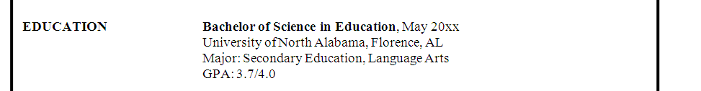

Experience (Work and/or Activities)– Positions should be listed in reverse chronological order. Be specific with dates, job titles, employers, and accomplishments. Be descriptive without being too long. Always be completely accurate and truthful. Be consistent in your format.

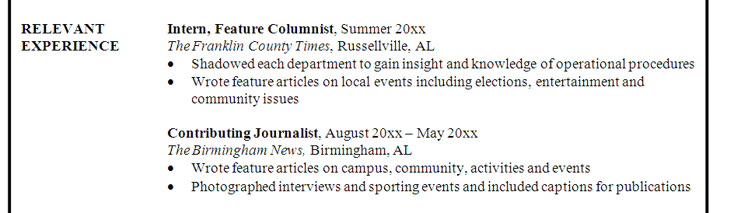

Use results oriented "action verbs"
to describe your experiences.
Use past tense action verbs for previous jobs and present tense action verbs for current positions.

SOMETIMES – Include some of these headings if they apply:
Honors, Awards, or Honor Societies
Leadership Experience
Computer Skills, Relevant Skills, Technical Expertise
Language Skills (Foreign or Computer)
Publications or Presentations
Professional Affiliations
Military Experience
Relevant Coursework
Objective

NEVER include this information!
Personal statistics (height, weight, marital status, health information, social security number, or other personal information unless the job specifically asks for it. Example: Law Enforcement may have to provide health related information.)
Photos of any type
References (or “References Available Upon Request”)—Include a separate page for references.
Political or religious information (unless it is relevant to the job)
Anything related to high school (exceptions: freshmen, sophomores and Education majors)
GPA, if below a 3.0 (unless specifically requested by an employer)

Creative Resumes—No matter how clever the design, a résumé will still need to convey to the employer your potential to bring value to the organization. If you put all your effort into the style of your résumé, you may neglect to develop the substance. Focus first on the content of your résumé. Think of creative projects you have done as a volunteer, organization member, employee, or intern that demonstrates your talents. Employers recommend promoting creativity through a portfolio. Research the organization to which you’re applying and try to determine if a more cutting-edge résumé design is your best bet. If the organization receives hundreds of résumés for each position, you might go with a design that will positively stand out from the rest. If using a more creative style, be mindful of the fact that some Applicant Tracking systems may not be able to read the graphics, textboxes, etc.

Resumes for Government Jobs— Résumés for federal jobs include more details than those written for jobs in private industries. You can begin building a résumé for federal employment in the same way you build any résumé--by listing jobs, skills, accomplishments, projects, leadership positions, and activities. After generating this list, visit www.federaljobresume.com or www.usajobs.gov to learn how to put your information into the required format.

International Resumes—If you are interested in working in another country, be sure to research guidelines for writing an appropriate résumé for your desired location. A resource that may help you is www.transitionsabroad.com.

The Military-to-Civilian Résumé —Military experience provides opportunities to develop a range of skills, many of which transfer to civilian jobs. When you review potential job descriptions, you may quickly identify specific responsibilities in the military that allowed you to learn or strengthen those skills and abilities. Once you begin targeting jobs, you’ll want to write a résumé that includes your military experience described in terms readily understood by someone without a military background. Avoid using military jargon, abbreviations, and acronyms. Focus on the skills you developed in leadership, communication, teamwork, management, supervision, training, translating, coordinating, planning, monitoring, and organizing. A resource to help you translate your military experience and job titles into terms familiar to civilian employers is the Veterans’ Employment & Training Service Transition Assistance Program: www.dol.gov/vets/programs.

Action Verbs

Each job duty on a résumé needs to begin with an action verb. Use past tense action verbs for previous jobs and present tense action verbs for current positions.

Achieved
Acquired
Adapted
Addressed
Administered
Advertised
Advocated
Aided
Analyzed
Applied
Approved
Arranged
Assembled
Assessed
Assisted
Attended
Brought
Built
Calculated
Charged
Checked
Clarified
Classified
Coached
Collected
Communicated
Compared
Composed
Computed
Conducted
Constructed
Contributed
Controlled
Cooperated
Coordinated
Created
Critiqued
Debated
Decided
Defined
Delegated
Delivered
Demonstrated
Designed
Detailed
Determined
Developed
Directed
Discovered
Displayed
Dissected
Distributed
Documented
Drafted
Earned
Edited
Eliminated
Enabled
Enforced
Engineered
Enlisted
Ensured
Established
Estimated
Evaluated
Examined
Exceeded
Executed
Expanded
Experienced
Experimented
Explained
Explored
Expressed
Extracted
Facilitated
Financed
Fixed
Followed
Formed
Formulated
Fostered
Founded
Gained
Gathered
Generated
Grouped
Guided
Handled
Helped
Hired
Identified
Illustrated
Implemented
Improved
Improvised
Increased
Indexed
Indicated
Influenced
Initiated
Innovated
Inspected
Inspired
Installed
Integrated
Interpreted
Interviewed
Introduced
Inventoried
Judged
Justified
Kept
Launched
Learned
Lectured
Led
Lifted
Located
Made
Maintained
Managed
Manipulated
Mastered
Maximized
Met
Modeled
Modified
Monitored
Motivated
Narrated
Negotiated
Observed
Obtained
Offered
Operated
Ordered
Organized
Originated
Overcame
Participated
Perceived
Performed
Planned
Practiced
Prepared
Presented
Produced
Projected
Provided
Questioned
Raised
Ran
Read
Reasoned
Received
Reconciled
Reduced
Referred
Related
Reported
Researched
Responded
Scanned
Scheduled
Served
Set goals
Sold
Solved
Specialized
Simulated
Strengthened
Succeeded
Summarized
Supervised
Supported
Tabulated
Tailored
Taught
Trained
Transformed
Translated
Unified
Upgraded
Utilized
Validated
Verified
Wrote

Professional References

- Your references should not be included on your résumé. List them on a separate page with the same heading as your résumé. Do not write “References Available Upon Request” on your résumé. It is assumed that you are able to provide references.
- Contact each person you intend to list as a reference and ask their permission. Ensure they are willing to provide a strong, positive recommendation. It is important that your references know you well and can speak to your character. It is also considerate to provide each reference with a copy of your updated résumé.
- Include the following for each reference: name, title, place of employment, business address (city, state, zip code), business telephone number, and email address.
- List 3-5 references. References can be an Academic Reference (professor, advisor, etc.) or a Professional Reference (employer, supervisor, etc.). Avoid “Personal References” unless they are specifically requested.

James Tee
James.tee@hotmail.com
1495 Lion Street
Florence, AL 35630
(256) 555-8234

REFERENCES

Mr. John Doe Ms. Sharon Watson
President Volunteer Coordinator
Alpine Camp for Boys Big Brothers/Big Sisters
1234 Maple Street 100 Mentor Lane
Mentone, AL 35555 Athens, AL 12223
(256) 555-5555 (256)123-1234
john.doe@mentonecamp.com sharon.watson@mentor.com

Dr. Jane Smith Dr. Adam Mooney
Professor Professor
University of North Alabama University of North Alabama
UNA Box 5066 UNA Box 5042
Florence, AL 35632 Florence, AL 35632
(256) 765-5555 (256) 765-4444
janesmith133@una.edu adammooney789@una.edu

Miss Susan Johnson
Store Manager
Logan’s Roadhouse
5555 Florence Blvd.
Florence, AL 35630
(256) 767-5555
susanjohnson@logans.com

INTERVIEWS

Job Interview Types

It is helpful to know the format of the interview in advance so that you can prepare accordingly. If the employer is not forthcoming with this information, consider asking about the format/schedule.

Screening Interviews are meant to weed out unqualified candidates. Providing facts about your skills is more important than establishing rapport. Often, the screening interview is a telephone interview.

Telephone Interviews are screening interviews designed to eliminate less qualified applicants so that only the best are invited for a personal interview. Phone interviews are typically scheduled in advance. Be sure you take the call in a quiet location, free from any distractions. If an interviewer calls unexpectedly, stay calm and answer their questions to the best of your abilities. Your goal is to provide concise, thoughtful answers and to be invited for a personal, face-to-face interview.

One-on-One Interviews are situations where you are face-to-face with just one other person. If invited to an interview, the employer has already established that you have the skills and education necessary for the position. The interviewer wants to see if you will fit in with the organization and how your skills will complement the rest of the department. Your goal in a one-on-one interview is to establish rapport with the interviewer and show him or her that your qualifications will benefit the organization.

Committee Interviews require that you face several members of the organization at one time. Each committee member generally has a say in whether you are hired, and they will take turns asking questions. Take your time responding, and try to find a way to connect with each person. Maintain eye contact primarily with the person who asked the question, but also look around the room and connect with the other committee members as you respond.

Group Interviews gather the front-runner candidates together in an informal, discussion-type interview. This type of interview is designed to gauge the leadership potential and interpersonal skills of the candidates. The interviewer will notice how you interact with others and use your knowledge and reasoning powers to influence others.

Lunch Interviews are especially difficult because in addition to worrying about interview questions and your answers, you need to be aware of your table manners, too! The setting may be more casual, but remember it is an interview and you are being watched carefully. Use the lunch interview to develop common ground with your interviewer. Follow his or her lead in both food selection and in etiquette.

Stress Interviews are a deliberate attempt to see how you handle yourself in an uncomfortable situation. The interviewer may be sarcastic, argumentative, purposely silent, or may keep you waiting. Remain patient and calmly answer each question as it is asked. Request clarification if you need it and never rush into an answer. If the interviewer lapses into silence, recognize this as an attempt to unnerve you. Sit still and remain silent until the interviewer resumes asking questions.

Virtual Interviews are very common as employers try to save time and money. If asked to do an online interview (i.e. Zoom, Skype), make sure that you are in a well-lit room with no shadows. Dress professionally, sit up straight, and look at the camera and smile. As tempting as it might be, don’t repeatedly look at yourself to check your appearance. Make sure the setting behind you is neat, clean, and organized.

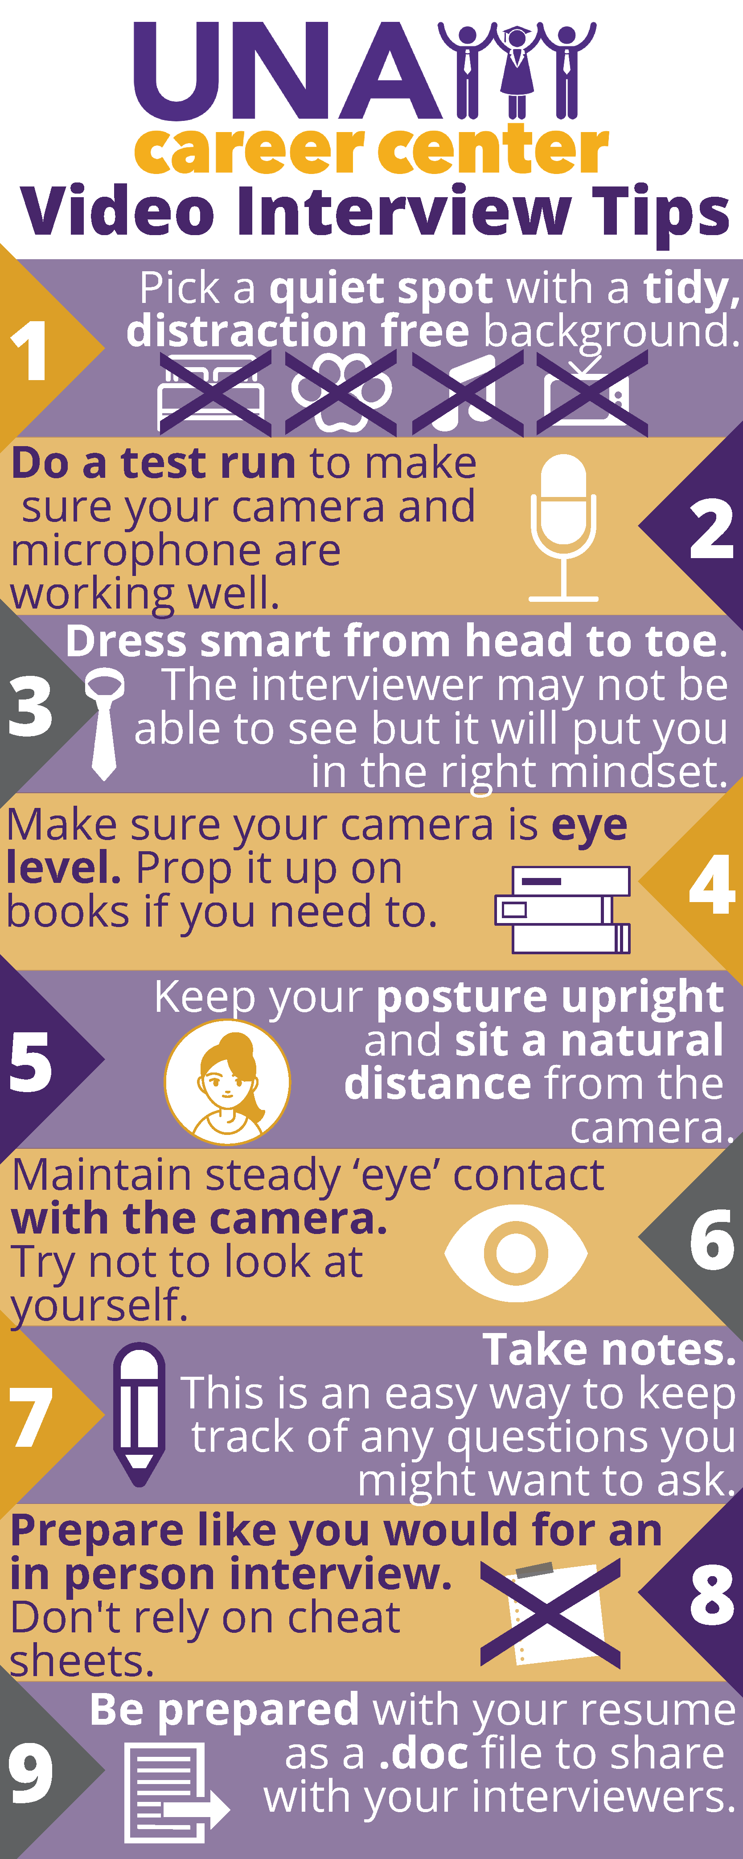

Interview Preparation
Make a good impression at your interview by preparing thoroughly.

Days Before the Interview
- Research the organization and the position. Find out as much key information as you can about the organization and its products, services, and customers. The more you know about the organization and the job, the better impression you will make in the interview. Things to know: mission/vision, annual sales, size/structure of the organization, locations, competitors, history, etc.
- Be prepared to sell yourself. Show enthusiasm, interest, and confidence. Know yourself and what you have to offer to the employer.
- Review lists of common interview questions and practice your answers out loud.
- Identify two or three of your top selling points. Determine how you will best convey them.
- Be prepared to provide examples of when things did not turn out as planned. What did you do?
- Review your résumé. Identify examples of situations where you have demonstrated the behaviors a given organization seeks.
- Rehearse your responses. You should be able to convey all pertinent details about yourself in 15 minutes. Tape yourself to check your diction, speed, and body language.
- Research current salary ranges for similar positions. If the employer asks, you should have a general idea of how much an entry-level employee earns doing similar work. It is safest to give a range (i.e. $25,000-$30,000).
- Prepare a list of questions to ask the employer, as that shows you are interested and engaged.
- Prepare your interview materials and have several copies of your résumé, a copy of your references, and, if appropriate, any work samples on hand. Make sure all are updated.
- Know what you want and why. Don’t be afraid to let the employer know that you want the job.

Before the Interview
- Be on time, preferably 5-7 minutes early. Do not be tempted to arrive too early. You will be in the way if they are not ready for you.
- Dress professionally and conservatively. You will be judged in some respects by what you wear.
- Bring a pen and notepad to jot down anything you may need to remember.
- Be positive and respectful when meeting others.
- Be confident. Have a firm handshake, make eye contact, and be aware of your posture.

During the Interview
- Show self-confidence and establish a rapport with the interviewer.
- Make eye contact, maintain proper posture, listen carefully, and respond in a clear voice.
- Be aware of any distracting overdone gestures (e.g., talking with your hands, raising your eyebrows).
- Avoid slang and use correct grammar.
- Relax! Take deep breaths, pause before answering questions, and stay calm.
- Ask the employer 2-3 questions at the end of the interview.

After the Interview
- End with a handshake, if appropriate, and thank the interviewer.
- Ask for the employer’s business card if you haven’t received it already.
- Send a thank you note within 24 hours of the interview.
- Follow up with a phone call within 7-10 days of the interview.
- Review your performance during the interview. Look for ways to improve next time.

Answering Interview Questions
Whatever the type of interview, you can be certain that the employer will be asking questions and that you will be expected to respond! Some questions will be general with straightforward answers. Other questions are likely to require more reflection; they could target past performance and behaviors and will require you to recall specific situations and your reactions.

When answering questions:
- Always make eye contact!
- Listen carefully to the question, ask for clarification if necessary, and make sure you completely answer the question that was asked.
- Use specific and detailed responses, not general responses. Whenever possible, use the STAR method to frame your response. This method provides a logical approach to answering any question:
S – Situation
T – Task

A – Action

R – Results

Describe the situation that you were in or the task that you needed to accomplish. Provide enough detail for the interviewer to understand. Quantify your results with numbers to illustrate your level of authority and responsibility. (Rather than “I was a shift supervisor,” explain that “As a shift supervisor, I trained and evaluated 4 employees.”)

Describe the action you took and be sure to keep the focus on you. Even if you are discussing a group project or effort, describe what you did—not the efforts of the team. Don't tell what you might do—tell what you did.

Describe what happened or how the situation ended. Focus on your accomplishments and what you learned.

Common Interview Questions

By reviewing interview questions, you will become more familiar with your own qualifications and will be well prepared to demonstrate how you can benefit an employer. Don’t try to memorize answers to these questions.

- Tell me about yourself.
- What are your strengths and weaknesses?
- What makes you stand out among your peers?
- How do you determine or evaluate success?
- What college subjects did you like best? Least? Why?
- What motivates you?
- Where do you see yourself in five years?
- What qualities should a successful manager possess?
- Why did you select your college or university?
- What led you to choose your major or field of study?
- Why did you choose the career for which you are preparing?
- In what kind of work environment are you most comfortable?
- How do you think you can contribute to our organization?
- What have you learned from participating in extracurricular activities?
- What are the most important rewards you expect in your career?
- What has been your most rewarding experience in college?

Use the STAR method to practice your answers to these sample questions:

- Tell me about a time when you had to go beyond the call of duty to get a job done.
- Describe a situation in which you were able to persuade someone to see things your way.
- Give me a specific example of a time when you used good judgment to solve a problem.
- By providing examples, convince me that you can adapt to a wide variety of people, situations, and environments.
- Tell me about a good decision you made recently.
- Describe a situation in which you worked as part of a team.
- Give an example of a goal you reached and explain how you achieved it.
- Describe a decision you made that was unpopular and how you implemented it.
- What do you do when your schedule is interrupted? Give an example of how you handle it.
- Have you had to convince a team to work on a project they weren't thrilled about? How did you do it?
- Have you handled a difficult situation with a classmate, co-worker, or supervisor? How?
- Tell me about how you worked effectively under pressure.
- Give me an example of a complex process or task you had to explain to another person or group of people.
- Talk about a recent problem you faced at work and how you found the best solution.

Questions to Ask the Interviewer

Employers will be expecting you to be prepared to ask 2-3 thoughtful questions. The questions you ask distinguish you from the other candidates. In some cases, your questions are more likely to be remembered than any answers you provide. Never inquire about salary, benefits, and/or company perks at an interview!

- Can you tell me what a typical day would be like?
- Can you explain the typical career path of someone entering this position?
- How often are performance reviews given?
- Does this organization promote from within?
- How much exposure to, and contact with, management is there?
- What are the commonly experienced satisfactions and frustrations of this job?
- What types of training programs do you incorporate?
- Some of my strong characteristics that I believe are applicable to this position are_______. What specific characteristics are you looking for?
- Where did the person who previously held this job go?

Career Fair Networking
The Career Center and employers alike suggest providing the following information for your introduction at a career fair:
- Name
- Class (senior, junior, sophomore)
- Major
- Opportunities that you are seeking
- Relevant experience (work, internship, volunteer work)
- Highlights of skills and strengths
- Knowledge of the company
Tailor your introduction to each employer based on good research and knowledge of each company—this will generally impress recruiters. A list of employers attending is usually available prior to the event. Most companies have web sites that provide information about their products and services. Other resources such as annual reports, press releases, and news coverage are also very helpful and can usually be found on the Internet.

Practice to perfection
Practice your introduction. “Winging it” is not a very wise plan of action, especially when a potential job is at stake. You’ll project confidence and charisma during your introduction if you are comfortable with what you are saying. The words you say, and your overall manner and confidence are critical components to the successful introduction. Your confidence and personality should be obvious in a professional way, not in an exaggerated or cocky way.
Incorporate positive nonverbal communications, such as eye contact, facial expressions, body language, posture, etc. A mirror, a friend, and/or a career services staff member are all good practice partners. Ask for constructive criticism and try it again.
Here’s a sample introduction:
Hello. My name is Kathy Thompson and I am a senior economics major at Catalina College. I noticed on Acme Financials web site that you have openings for financial managers, and I am interested in a position in this capacity. Last summer, I had an internship with Johnson Financial and was able to participate in a variety of company operations. The most interesting project I worked on was redesigning the company’s service demonstration events for the Southern California region. This was invaluable training because it afforded me greater insight into the finance industry and allowed me to show my ability as a team player. Perhaps best of all, it confirmed my desire to become a financial manager for a top-10 firm, such as Acme Financial. I have been following your company’s expansion into the greater Los Angeles area in the L.A. Times. I also read in Acme Financials annual report that it is considering establishing operations elsewhere in Southern California. Could you tell me more about this proposed expansion? Could you also tell me about your financial management training program?
Reprinted from JobWeb (www.jobwell.com), with permission of the National Association of Colleges and Employers, copyright holder.
Interview Attire

Dress Code for Men

- Wear a dark tailored suit (navy, charcoal, or gray are recommended) with a starched long-sleeved white shirt to give a more professional appearance.
- Invest in an updated silk tie with a tasteful, conservative pattern. Blue ties with simple patterns (dots or stripes) are most often recommended. Bow ties are not recommended for interviews.
- Match your belt with the color of your shoes (black or brown). Make sure your shoes are polished and your socks coordinate with your suit. Avoid light colored socks with a dark suit.
- Jewelry should be worn in moderation (wedding ring and/or class ring, watch).
- Grooming tips: cleanly shaven or neatly trimmed facial hair; clipped fingernails; hair freshly cut, not below base of neck; no visible body piercings or tattoos; avoid cologne and aftershave, use only deodorant. DO NOT SMOKE before your interview.
- Carry a briefcase and/or portfolio to enhance your overall professional appearance.
- If using breath mints, finish before greeting the recruiter; do not use gum.
- When in doubt about how to dress for an interview, dress conservatively and professionally.
- Do not button the bottom button of your suit jacket.

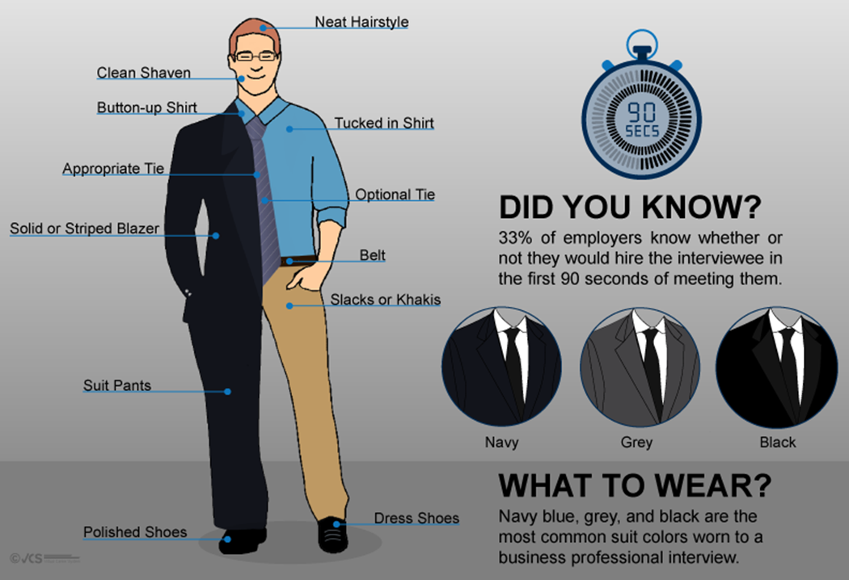
Dress Code for Women

- Wear a two-piece business suit in a dark or neutral color
- Avoid ill-fitting (short, tight, clingy, or slit) skirts; skirts should be no higher than your knee when you are standing.
- When choosing a shirt, select a classic, tailored blouse in cotton or silk fabric with a conservative neckline; low-cut tops and other revealing clothing do not make for a professional appearance.
- Wear simple classic heels with a closed heel and toe (black, navy, brown, or taupe).
- Jewelry should be worn in moderation (only 1 ring on each hand; simple and one-toned watch, earrings, bracelets, or necklaces; no costume jewelry).
- Grooming tips: hair should be natural color; if not, beware of off-colored or contrasting roots; if hair is longer or your style is flowing and wispy, wear it pulled back away from your face; no visible body piercing beyond conservative ear piercings; no visible tattoos; make-up should be natural; avoid perfume, use deodorant only; nails should be well manicured. DO NOT SMOKE before your interview.
- Carry a briefcase and/or portfolio to enhance your overall professional appearance.
- If using breath mints, finish before greeting the recruiter; do not use gum.
- When in doubt about how to dress for an interview, dress conservatively and professionally.

“You never get a second chance to make a first impression.”

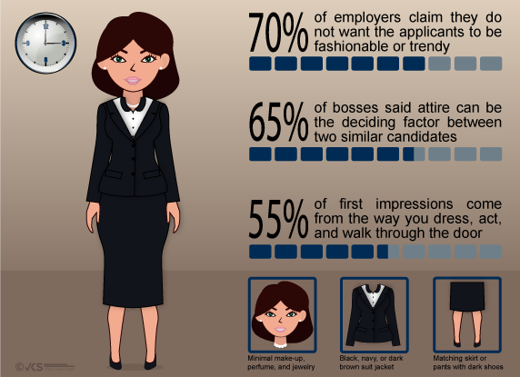
Dining Etiquette

Often an employer will take potential candidates to lunch or dinner to continue the interview process. This is an opportunity for the employer to observe candidates in a more conversational setting; however, it is important to be mindful of social etiquette. This is still a job interview and your communication skills, interpersonal skills, and manners are all being critiqued.

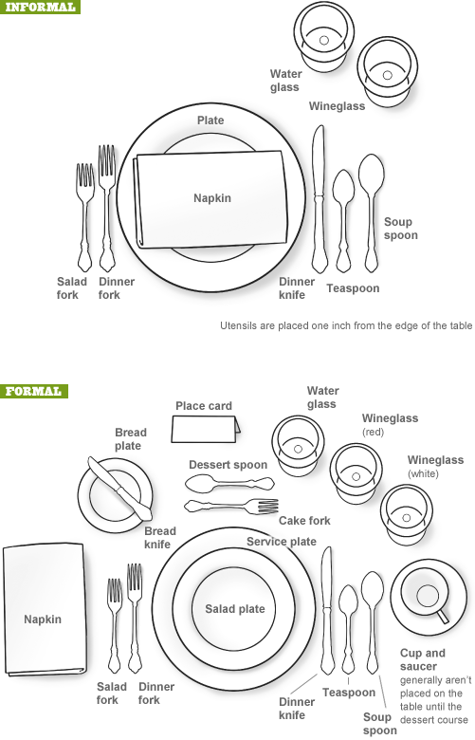
General Etiquette
- Unless expecting an emergency call, turn off your cell phone and other electronic devices
- Have proper posture and keep your elbows off the table
- Participate in the conversation
- Follow the lead of the host

Sitting Down
- Do not place any bags, purses, sunglasses, cell phones, or briefcases on the table
- When all are seated, unfold your napkin and place it on your lap, folded in half with the fold towards your waist
- Wait for all parties to arrive before beginning any part of the meal

Ordering
- Don’t order the most expensive item
- Order simply; don’t ask for many substitutions
- Avoid finger foods or foods that are difficult and messy to eat
- In general, don’t order alcohol at a business meal, even if others do

While Eating
- Wait for everyone to get their meal before starting
- Take small bites and don’t talk with your mouth full
- Cut your food into bite size pieces if necessary
- Break your bread/rolls and butter each piece individually
- Gently stir your soup to cool it instead of blowing on it; spoon your soup away from you
- Try to pace yourself to finish at the same time as everyone else
- If something undesirable is in your mouth, discreetly remove it with your fork
- If you leave the table, excuse yourself and place your napkin on your seat

After Eating
- When finished, place your napkin neatly to the left of your plate; don’t push your place setting away from you
- If you don’t finish your meal, don’t ask for a doggy bag!
- Assume that the employer will pay the bill and tip
- Remember to thank the employer for lunch/dinner

Thank You Notes

Writing a thank you note after your interview won't necessarily help you secure the job, but not sending one will most certainly hurt your chances. You should write a follow-up letter immediately after each interview, ideally within twenty-four hours. Hand-written notes, hard copy letters, and emails are acceptable formats. Sending emails might be more manageable if you’ve met with many different recruiters. Emails are certainly received faster and may be the best option if you’re uncertain of the hiring timeframe. Each thank you note should be brief and personalized. Try to recall a moment from your interview. Be sure to:

- Express your appreciation for the opportunity to interview with the recruiter
- Express your continued enthusiasm about the position and the organization
- Recap your strengths, being careful to relate them to the requirements of the job and the organization
John Smith
256-555-5555
john.smith@gmail.com

February 9, 2016
Mr. Andrew Hur
Putnam, Hayes, & Bartlett, Inc.
10940 Boulevard Road, Suite 1500
Huntsville, AL 35802

Dear Mr. Hur:
It was a pleasure meeting with you yesterday regarding the research assistant position. I enjoyed learning more about the opportunity and about Putnam, Hayes, & Bartlett, Inc.
The position is exciting and seems to encompass a diversity of responsibilities. I believe that with my experience and skills, I'm qualified to make a valuable contribution to your organization.
Should you require additional information, please don't hesitate to contact me at the telephone number listed above or at (312) 555-1212. I look forward to hearing from you.

Sincerely,

Your Signature Here

John Smith

Life After College

Organizational Behavior and Office Politics
- Take time to learn how to work with new managers, as your success is intertwined with theirs.
- Learn to listen to others and seek advice; don’t try to prove yourself all the time.
- Consider what others on a team have to say, and work together. The ability to work well with others is essential to progressing in your career.
- If no mentor is set up for you, find one for yourself.
- Be careful what you say about others; protect your image; know who can be trusted and who cannot.
- Adapt to the organization’s style and culture; don’t be afraid to ask questions.
- Volunteer for projects and committees, but don’t line up more work than you can handle.
- Show enthusiasm and take initiative. Offer to help others with projects as time allows.
- Remember that you are in charge of your own career; don’t blame others if it’s not going the way you want.
- If you make a mistake, take responsibility and communicate with management. Always develop and provide your manager with a sound plan of action to address any shortcomings.

Effects of Breaking the Law
- Any criminal record can have a disastrous effect on your career. You won’t be eligible for teacher certification; you won’t get security clearance for military, state, or federal jobs; you will have trouble getting a job in a medical field where there is access to controlled substances; you may not be eligible for jobs requiring travel if you have driving offenses.

Moving
- Know what your needs are in a home or apartment.
- When you look at properties, check to make sure everything works as it should.
- Read leases carefully and discuss any questions or concerns with the landowner.
- Complete a condition report so you have a record of any damages already made to the property. If not, you may lose your security deposit for something you didn’t do.
- Consider all costs: moving expenses, deposits, utilities (there is a charge to hook them up when you move in, and you need to have an idea how much they’ll run per month), phone, Internet access, water, cable, trash pickup, insurance, etc.

Money Matters/Financial Planning
- Make a budget and stick to it. Keep track of your expenses so you can tell where your money is going.
- Keep only one credit card and use it only in real emergencies. Credit cards are convenient but can quickly lead to significant financial issues.
- Paying just the minimum each month keeps you barely ahead of the finance charges.
- It’s never too early to start saving. Invest in tax deferred accounts and strive to take full advantage of any employer matching. Starting investments early in your career is the key to long-term success. Utilize raises and cost of living adjustments as opportunities to increase your contributions.
- Use your employer’s automatic savings plan. If you never see the money, you won’t miss it.

Insurance
- Health insurance is a must; keep premiums lower by selecting high deductibles and coinsurance.
- If you’re renting, it’s important to have renter’s insurance - the landowner’s policy will not cover your belongings.
- Homeowner’s or renter’s insurance generally covers fire, storms, theft, liability, etc., but most do not cover flood. If you are in a flood zone, consider adding flood insurance.
- Get coverage for replacement costs. It’s more expensive, but if you don’t, you could end up getting $100 for something that will cost you $500 to replace.
- Life insurance should cover paying off your debts and your funeral. If you have a family, you’ll need more. Term life insurance policies generally have much lower premiums than whole life insurance policies.
- Disability insurance is more common than life insurance among people under 65. Get coverage at 50-60 percent of your income.

Negotiating Salary

When it comes to negotiating a starting salary, here are some recommendations:

Educate yourself on the company. Understand the job for which you are applying, including the responsibilities, requirements, and expectations for the position. Ensure you’ve asked and understand how the company reviews employee performance, the process for pay raises and promotions, and other fringe benefits of the job. This is a good discussion to have with the HR person during the telephone screening interview. Let the interviewer bring up the topic of salary.

Arm yourself with salary information. Spend adequate time conducting research to find out average salaries and salary ranges for similar jobs in your area, industry, and geography. There are many websites that provide salary information, including: Salary.com, PayScale, Indeed, CareerOneStop, Glassdoor, U.S. Bureau of Labor Statistics, and Job Search Intelligence.

Know your strengths and differentiators. What makes you special and unique from everyone else? What are the differentiators and the special skills or experiences that could make you a valuable employee? Ensure you have these differentiators written down as this information can then be used as leverage to negotiate a higher starting salary with the hiring manager.

Decide on an appropriate salary range. Based on your research of similar jobs in your geography and industry, come up with what you think would be an appropriate salary range for the job. Your target salary should fall within this salary range.

Define your “walk-away” point. Now that you’ve determined your target salary and an appropriate salary range, think about the minimum salary you’re willing to accept and why you’d accept that amount. Then, consider the reasons why you’d be unwilling to accept a lower amount. Write these reasons down, as you may need to pull them out for your discussion with the hiring manager during the salary negotiation.

Practice your negotiation skills. Ask a friend or family member to play the role of a hiring manager who has offered you a salary that is lower than what you want. Then practice what you’ll say and how you’ll say it to persuade the hiring manager to increase their offer.

Keep in mind that it’s in the hiring manager’s best interest to carefully determine the salary offers they make to new employees. This is because they need to make sure their compensation offers are internally and externally competitive and offer the same salary range to employees currently working in the same or similar positions based on education, experience levels, and productivity. At most companies, a lot of research and analysis goes into every salary offer before the job offer is ever made.

That isn’t to say you shouldn’t negotiate for a higher salary – pursue it if you believe you have good reasons for the request. This is especially true if you have specialized skills or training that are in short supply or worth more to the company. Most hiring managers will usually start with an amount that is lower than what they are willing to pay because they assume the candidate will try to negotiate upward. Negotiation is a skill you can hone, and it’s up to you to get what you want and what you deserve.

Reference: http://www.forbes.com/sites/lisaquast/2014/03/31/job-seekers-8-tips-to-negotiate-your-starting-salary/

Monthly Budget Worksheet

Congratulations, you have been offered the job! Now you can begin planning your new monthly budget.

Monthly Gross Pay $_________________________
Subtract 15% for taxes $_________________________
Subtract 10% for 401K/Retirement Contribution $_________________________

TOTAL Take-Home Pay $_________________________

Typical Living Expenses:
Savings $_________________________
Rent $_________________________
Student Loan Payment (if applicable, approximately 8%) $_________________________
Renter’s Insurance $_________________________
Electricity and Water $_________________________
Phone/Cable/Internet $_________________________
Car Payment (including insurance) $_________________________
Food (groceries and dining out) $_________________________
Gas for car $_________________________
Medical and Dental Expenses (out of pocket) $_________________________
Clothes $_________________________
Hair Care and Maintenance $_________________________
Gifts/Charitable Contributions $_________________________
Gym/Health Club Memberships $_________________________
Entertainment (movies, ball games, concerts, trips) $_________________________
Digital Media/Magazine Subscriptions/Books $_________________________
Pet Expenses $_________________________

TOTAL Living Expenses $_________________________

SAMPLE PART TIME JOB RESUME FOR FRESHMEN

Mary Smith
msmith21@una.edu
205-555-5555

Education Bachelor of Business Administration, May 2024
University of North Alabama, Florence, AL
Major: Marketing

Advanced Diploma, May 2020
Hoover High School, Hoover, AL
GPA: 3.8/4.0

Experience Crew Member, May 2018-August 2020
McDonald’s, Homewood, AL
- Provided customers with quick and accurate service
- Prepared and cooked food
- Maintained cleanliness and good hygiene according to standards

Childcare, Summers 2017- 2019
Williams Family, Hoover, AL
- Supervised activities in children’s rooms and play area
- Planned, prepared and arranged nutritious meals for children
- Transported children to and from school or other activities
- Performed child related everyday jobs as directed by parents

Community Special Olympics, August 2014-Present
Service Relay for Life, May 20014, 2015, and 2016

Computer Microsoft Office Programs
Skills Windows XP, Vista

Honors National Merit Finalist
Coca Cola Dream Scholarship

Activities National Honor Society, April 20014-May 2016
Hoover High School Marching Band, August 2012-May 2016
Spanish Club, 2014-2016

College of Arts and Sciences Sample Resume

Mary Helper
jrc@una.edu
(256) 555-7899

Education Bachelor of Social Work, May 2022
University of North Alabama, Florence, AL
GPA: 3.8/4.0

Associate in Applied Science, December 2020
Northwest Shoals Community College, Muscle Shoals, AL
GPA: 4.0/4.0

Experience Student Intern, August 2021-Present
Make Believe Hospital, Florence, AL
- Serve as family service assistant, conducting assessments and making referrals
- Co-facilitate development of parent/teen support groups
- Refer patients to community resources during prenatal and postpartum stages

Service Learning, January 2019 – May 2021
Mitchell Hollingsworth, Florence, AL
- Assisted nurses with resident activities
- Created a newsletter for resident families

Discharge Planning Assistant, May 2017-August 2020
Pretend Medical Center, Atlanta, GA
- Organized resource packets for hospital pregnancy clinic
- Updated and maintained filing system to improve follow-up rate
- Provided office support for eight full-time employees

Volunteer, Peer Contacts Program, January 2016-August 2017
Not Real Clinic, Birmingham, AL
- Compiled and organized resource information for young mothers
- Coordinated monthly educational programs
- Served as mentor to parents, providing support and information

Professional National Association of Social Workers (NASW) Student Chapter
Association ABC Human Services Council

Honors/ Gamma Beta Phi Honor Society
Activities Alpha Delta Pi, Standards Committee, 2019-Present
Meals on Wheels, Volunteer, 2017-2020

College of Arts and Sciences Sample Resume

Heather Mapps
(256) 123-4567
heather.mapps@gmail.com

Education Bachelor of Science, May 2022
University of North Alabama, Florence, AL
Major: Geography (Option: Geographic Information Science)
Minor: Computer Information Systems
GPA: 3.2/4.0

Computer Skills Proficient use of Microsoft Office Suite, Windows XP and Vista
Experienced user within ERDAS Imagine and ArcGIS 9.3

Related Geographic Information Systems Intern, December 2020-Present
Experience ISC, Huntsville, AL
- Create maps and update spatial data within Spatial Database Environment
- Utilized GIS technology and techniques to analyze multiple resources for a variety of projects
- Gained knowledge of land use planning and classification
- Evaluate source material for map production for a variety of projects
- Assist co-workers with advice in the development and construction of maps
- Use a variety of techniques to evaluate and update existing feature classes

Student Projects, 2018-2020
University of North Alabama, Florence, AL
- Worked on several projects with guidelines using ArcMap software (data and instructions provided by professors)
- Researched and gathered information on a potential landfill site
- Studied a variety of planning mistakes in various cities and offered possible solutions
- Researched Alabama wildlife to determine the impact that an invasive species has on the state’s residents and other wildlife

Other Experience Server/Trainer, January 2017-Present
Outback Steakhouse, Sheffield, AL
- Promoted to trainer after 6 months
- Train new servers on protocol and procedures
- Serve as hostess and develop seating charts when needed
- Ensure efficient customer service and customer satisfaction

College of Arts and Sciences Resume Sample

John A. biologist
(256) 987-6543
jabiologist@una.edu

EDUCATION
Bachelor of Science, December 2022
University of North Alabama, Florence, AL
Major: Biology

EXPERIENCE
Field Experience & Field Skills:
- Collected & released crayfish, studied their population distribution patterns; populations of woodlice also studied
- Collected, pressed, keyed, and identified several local plants: trees, flowers, mosses, liverworts, ferns, algae
- Collected, keyed, and identified several local vertebrates (or their remains): deer, foxes, armadillos, lizards, frogs, rodents, birds, fish
- Performed tests of, and recorded environmental parameters, including: temperature, rH, soil moisture, foot-candles, ppm, pH, dominant species
- Located and identified which kind of animal left specific tracks

Lab Experience & Lab Skills:
- Experienced with microscope: dissecting and compound light microscopes; light field, dark field, and phase contrast microscopy; utilization of stains
- Identified, cultivated, streaked bacterial plates, performed bacterial colony counts, and bacteriophage plaque counts, and experimented with microorganisms
- Performed several laboratory procedures: Pipetting, micropipetting, vortexing, microcentrifugation, TLC, column chromatography, polymerase chain reaction
- plasmid insertion, gel electrophoresis, gel analysis, Southern blot, Western blot, dot blot, fluorescent in situ hybridization (FISH), enzyme-linked immunosorbent assay (ELISA), recombinant DNA experiments, used a spectrophotometer, studied Beer-Lambert law
- Dissected numerous plants and animals for anatomical study and taxonomic study
- Studied biological diversity of flora & fauna, both large and small; analyzed owl pellets
- Can create & edit charts, graphs, and tables; can use Microsoft Excel, PowerPoint, and Word

ADDITIONAL EXPERIENCE
Sales Associate, Pet Depot, Florence, AL, August 2016 - Present
- Maintain all live animals in store including feeding and grooming
- Perform customer service including sharing knowledge of all aspects of pet ownership for a wide variety of animals

College of Arts and Sciences Resume Sample

Mollie Safety
256-444-1111 ihsaftey@una.edu

EDUCATION

Bachelor of Science, December 2022

University of North Alabama, Florence, AL

Major: Chemistry and Industrial Hygiene

GPA: 3.0

APPLICABLE INDUSTRIAL HYGIENE COURSEWORK

- Toxicology
- Ergonomics
- Air Sampling Methods

Safety

Industrial Hygiene Management

INDUSTRIAL HYGIENE EXPERIENCE
Industrial Hygiene Intern, BP Chemical, KBR, Decatur, AL, 2020-2021
- Worked Para xylene unit outage
- Monitored chemical exposures for first line breaks
- Conducted noise monitoring
- Enforced safety regulations
- Audited JSA’s

Student Intern, Assistant, Tennessee Riverkeepers, Decatur, AL, 2019-2020
- Provided technical assistance along with support to management
- Processed water samples
- Designed brochures for awareness on keeping rivers clean
- Reviewed state regulatory reports to determine organizations who were over state mandated water waste limits
- Coordinated outreach event to raise funds and awareness of water protection

Student Projects, University of North Alabama Department of Industrial Hygiene, 2018-2020
- Conducted noise sampling at Wise Alloys
- Facilitated mock hazardous waste spills on campus

HONORS AND ACTIVITIES

Vice President, American Industrial Hygiene Association Student Chapter

American Chemical Society, Student Chapter

Granted NIOSH scholarship

College of Arts and Sciences Resume Sample

SALLY R. COMMUNICATE
srcommunicate@gmail.com (256) 987-6543

SUMMARY OF QUALIFICATIONS
- Excellent written and oral communication skills
- Experienced in event planning and community outreach
- Proficient with InDesign, Microsoft, HTML and Final Cut Pro7

EDUCATION
Bachelor of Science, May 2022
University of North Alabama, Florence, AL
Major: Mass Communication Concentration: Public Relations
Honors: Dean’s List, Omicron Delta Kappa

EXPERIENCE
Media/Community Relations Intern, Shoals Hospital, Muscle Shoals, AL, 2020-Present
- Organize corporate events and coordinate media coverage with Media/Community Relations Director
- Design and produce hospital information brochure and education boards
- Assist in retail sales within hospital gift shop
- Maintain hospital’s Facebook and Twitter pages

Public Relations and Showroom Sales Representative, S.B.S. Electric, Florence, AL, June 2019-October 2020
- Organized PR event at “The Big Deal” in partnership with the University of North Alabama
- Provided quality customer service by assisting clients in choosing the proper indoor/outdoor lighting
- Maintained showroom area displays, catalogs and price sheets
- Assisted with TVA energy efficiency lighting audit for Marriott Shoals, Shoals Conference Center and 360 Grille

Communications Intern, Shoals Chamber of Commerce, Florence, AL, July 2018-December 2018
- Coordinated and served as emcee for NCAA Division II National Championship Football Banquet
- Introduced communications plan to local businesses to help support the Chamber of Commerce’s campaigns
- Served as Chamber liaison to new residents of the Shoals
- Designed and edited Shoals Chamber of Commerce membership book
- Designed website and competition sponsor board for BEST Robotics program

LEADERSHIP PROJECT EXPERIENCE
F.A.M.E. Sheriffs’ Girls’ Ranch, Executive Manager of Events & Vendors, Muscle Shoals, AL, January 2016-October 2018
- Organized “The Kid’s Corner”
- Filmed and edited video trailer
- Assembled sponsor media packets and managed social media sites

Randy Owen Celebrity Golf Classic, Muscle Shoals, AL, January 2015-June 2015
- Worked with hostess on organizing schedule of events
- Coordinated golf tournament hole fundraisers

COLLEGIATE INVOLVEMENT
- Zeta Tau Alpha
- UNA PRIDE (Public Relations Individuals Dedicated to Excellence), Member
- Public Relations Student Society of America, Student Member
- Public Relations Council of America/North Alabama Chapter-Public Relations Council of Alabama, Student Member
- Southern Public Relations Federation, Student Member

College of Nursing Sample Resume

Marcus B. Ready
mbready@hotmail.com
(256) 789-1234

Education Bachelor of Science in Nursing, May 2015
University of North Alabama, Florence, AL
GPA: 3.5/4.0

Certification Alabama Board of Nursing
Licensure Eligible to take National Council of Licensure Exam (NCLEX)
Advanced Basic Life Support, American Red Cross, expires 2020

Experience Preceptorship, January 2015-April 2015
Eliza Coffee Memorial Hospital, Emergency Department, Florence, AL (36 hrs)
- Administered medication (intramuscular injections, PO, IV piggy backs, IV push, PO charcoal lavage) under supervision of preceptor and observed roles and responsibilities of charge nurse
- Performed nursing assessments and practiced registered nursing skills

Internship, January 2014-April 2014
Helen Keller Hospital, Emergency Department, Sheffield, AL (48 hrs)
- Performed venipuncture, inserted foley catheters, administered medications, functioned as a triage nurse, drew blood and assisted with rapid response
- Assisted Physician and/or N.P. with procedures such as inserting wick dressing, shoulder displacement, lancing and draining an abscess, and assisted with fluorescein eye stain

Nursing Student, 2014-2015
Eliza Coffee Memorial Hospital, Pediatrics, Florence, AL
Handy Homes Community Health Clinic, Florence, AL
Phil Campbell Elementary School, Phil Campbell, AL
Decatur General West, Decatur, AL
University of North Alabama, College of Nursing, High Fidelity Simulations, Florence, AL
- Performed nursing assessments and basic nursing skills, composed and implemented individual care plans, delegated and prioritized patient care
- Taught health promotion to patients and elementary students, composed and implemented, composed SOAP notes on individual patients, administered medications (intramuscular and subcutaneous injections), assisted with annual health fair
- Observed nurse addressing psychological issues faced by children and engaged in therapeutic communication with mental health patients

Additional
Experience Server, August 2013 – Present
Ricatoni’s Italian, Florence, AL
College of Business Sample Resume
Seth Paige
(205) 814-5210
sethpaige@email.com

Education Bachelor of Business Administration, December 2014
University of North Alabama, Florence, AL
Major: Accounting GPA: 3.5/4.0

Relevant Accounting Intern, Summer 2014
Experience Wise Metals Group, Florence, AL
    - Assisted with month end financial report
    - Posted journal entries
    - Assisted with audits
    - Supported payment processing team
    - Worked with finance team on yearly forecasting efforts

Keyholder/Sales Representative, April 2013-May 2014
Pretty Clothes, Mayfield, AL
- Fitted toddlers in shoes designed for their age group
- Completed a daily sales report
- Suggested latest baby fashions to customers
- Managed cash register and counted down drawer
- Made daily deposit totaling up to $2000
- Opened and closed the store

Leadership Student Government Association
Experience President, 2012-2014
    - Collaborated with UNA Athletic Department to increase campus spirit by providing promotions and incentives for all students to attend athletic events
    - Worked with Florence City and University Police to gain access to the downtown parking garage to improve parking for all students
Executive Council—Senate Pro Tempore, 2012-2014
- Advised the Freshman Forum Branch
Senator—Student Welfare Committee, 2012-2014
Freshman Forum—Service Committee, 2012-2014

LaGrange Society
University Ambassador, 2012-2014
- Awarded LaGrange Society “Rookie of the Year” 2012-2013
- Served as a Host at home football games, commencements and other official events
- Helped raise funds for Leo and Una, UNA’s live mascots

College of Business Sample Resume

MICHELLE MCMILLION
(256) 724-4336
mmcmillion@email.com
EDUCATION Bachelor of Science, May 2015
University of North Alabama, Florence, AL
Major: Computer Science
Minor: Human-Computer Interaction/User Experience (HCI/UX)
GPA: 4.0/4.0

RELEVANT Assistant Web Developer, October 2014-present
EXPERIENCE Dynetics Technology, Huntsville, AL
      - Develop applications for the company website with PHP/MySQL/Javascript/HTML/CSS
      - Manage and design website layouts with HTML/CSS
      - Lead one-on-one training for the site’s Content Management System (CMS)
      - Edit videos and create graphics

Student Web Developer, September 2014-May 2015
North Alabama Collaborative Education, Florence, AL
- Develop website applications for cpr2.org using PHP/MySQL/Javascript/HTML/CSS
- Use Git as version control/collaboration system
- Penetration security testing

Video Editor/Technical Assistant, Summers 2012 - 2014
Greenscreen, Muscle Shoals, AL
- Videography and video editing for interviews and documentaries
- Custom software development
- Create graphics for website

COMPUTER
SKILLS Programming Languages
- C++, Java, Python, PHP, Javascript
Database Languages
- MySQL, MongoDB
Web Development
- HTML, CSS, Bootstrap, Wordpress, PHP, MySQL, NodeJS, MongoDB, Python, Django
System Administration
- Linux Terminal, Linux Installation, Windows Administration
Software Development Tools
- Git, Apache Server, Dev C++, Notepad++, FileZilla, WinSCP, Putty
Prototyping Computers, Robotics
- Arduino, Raspberry Pi, BeagleBone
Digital Media Software
- Photoshop, Gimp, Inkscape, Sony Vegas, Microsoft Word/Excel/PowerPoint

INDEPENDENT Owner/Manager, Fall 2013-present
ACTIVITIES McMillion Web Services, Florence, AL
Portfolio: portfolio.mcmillion.com
      - Develop customized websites for clients
      - Development with PHP/MySQL/Javascript/HTML/CSS
      - Use of Content Management Systems (CMS’s) such as Wordpress, Drupal, MODX

3 Day Startup, University of North Alabama College of Business, February - March, 2015
- Selected as one of 40 participants to rapidly develop a business in 3 days
- Developed a semi-functional prototype to demonstrate at the final pitch to investors

College of Education and Human Sciences Sample Resume: Teaching

Tisha Smith
(256) 867-5309
tishasmith@emaildomain.com

Education Bachelor of Science in Education, May 2015
University of North Alabama, Florence, AL
Major: Secondary Education, Language Arts
GPA: 3.5/4.0

Certification Class B, Language Arts Education (6-12)
Lee vs. Macon
HIGHLY QUALIFIED

Experience Intern, 8th and 9th grade English Composition, January 2015-May 2015
Florence High School, Florence, AL
- Prepared daily classroom lessons using new technologies
- Instructed approximately 110 students
- Computed student grades and averages
- Developed activities incorporating multiple learning styles
- Communicated with parents regarding student progress
- Managed classroom and maintained organization

Practicum Experience (150+ hours), August 2013-December 2014

Colbert Heights High School
Sheffield Junior High School
Kilby Lab School
Florence Freshmen Center
McBride Elementary School
Clements High School
West Limestone High School

- Introduced Shakespeare to 6th graders at Kilby Laboratory School and conducted an interactive lecture once a week for six weeks, Fall 2014
- Accompanied 8th grade of Clements High School on field trip to the University of North Alabama, May 2014
- Prepared a three week all-inclusive unit on the novel Delirium by Lauren Oliver

Daycare Provider, February 2014-February 2015
Little Anna’s Daycare, Florence, AL
- Provided care for approximately ten children ages 2-4 years old
- Organized classroom activities to engage children and teach basic information such as colors, numbers, and alphabet

Honors/ Member, Phi Kappa Phi
Activities Member, Kappa Delton Epsilon
Member, Education Organization
- Organized membership drive and increased membership by 25%
- Visited local high schools and shared information on education as a career option

College of Education and Human Sciences Sample Resume: Non-Teaching

MICHAEL F. JORDAN
(256) 456-7890 mfjordan1@una.edu

Education

Bachelor of Science in Health, Physical Education and Recreation, May 2015
University of North Alabama (UNA), Florence, Alabama
Concentration in Exercise Science
GPA: 3.5/4.0
SPECIAL Skills

- Submaximal VO2 Fitness Testing
- Flexibility Fitness Testing
- Body Composition Testing
- Skinfold Calipers
- Hand Grip Fitness Testing
- HIPAA Training

- NIH Human Subjects Training
- Sphygmomanometer Blood Pressure Reading

Related Experience

Internship, Advanced Therapy Center, Muscle Shoals, Alabama, Spring 2014
- Observed therapists instruct patients in exercise programs
- Operated therapy equipment (ultrasound/electrical stimulation machine, exercise machines)
- Performed different office and staff tasks (filing, laundry, cleaning, answering phones)

Volleyball Coach, Covenant Christian School, Florence, Alabama, 2013-2014
- Served as Head Coach for Junior Varsity Girls and Assistant Coach for Varsity Girls
- Prepared practice itinerary
- Instructed girls during practice and games

Research Experience

Harlan Pedometer Research Project, Fall 2014
- Assisted teachers with their goal setting each week
- Composed of teacher volunteers from an elementary school
- Project was designed to compare the number of steps taken each week from a control group (teachers simply wearing a pedometer throughout the school day) and an intervention group (teachers wearing a pedometer every school day along with having goal setting each week and motivational tips each day)

Additional Experience

Student Assistant, University of North Alabama Continuing Studies, 2013-2015
- Prepared materials for weekly workshops

Honors/Activities

Leadership Scholarship—UNA, full tuition, Fall 2011-Spring 2015
Muse Estate Endowed Scholarship—UNA, Fall 2011-Spring 2015
Dean’s List, 4 semesters
Honor’s Program Scholarship—UNA, 2011-2015
W.C. Handy Festival Design Contest Winner, 2015

Professional Affiliations

The Honor Society of Phi Kappa Phi, 2011-2015
Undergraduate Service Award Nominee, 2013
Honor’s Program, 2011-2015
Alabama State Association for Health, Physical Education, Recreation and Dance (ASAHPERD), 2011-2015

College of Education and Human Sciences Sample: Non-teaching

Michelle Thread
256-766-1111, mthread@una.edu

Education
Bachelor of Science in Human Environmental Science December 2014
University of North Alabama, Florence, AL
Concentration: Interior Design Minor: Art
GPA: 3.6/4.0

Experience
Intern, Smith Designs and Décor, Florence, AL May 2014-Present
- Participated in meetings with clients to determine space needs of renovation projects
- Completed inventories of spaces, focusing on potential environmental problems
- Assisted in creating renovation time-lines and coordinating with contractors
- Selected paint colors, furniture, and wall prints for homes

Sales Associate, Bath and Body Works, Florence, AL April 2012-November 2014
- Researched and promoted new products and their effectiveness
- Helped organize stock room to ensure speediness of product replenishment
- Designed and set up effective window displays
- Motivated fellow associates to help reach daily and weekly sales goals

Activities
UNA Chapter, National Kitchen and Bath Association
Society of Interior Designers (ASID) Student Chapter
UNA Fashion Forum, Vice President, September 2012-May 2014

Design Skills
AutoCAD 2014, Google Sketch-Up, Technical Hand Drafting, Hand Rendering, Microsoft: Visio, OneNote, Access and Publisher

Relevant Coursework
Business Codes and Practices-Drawing I, History of Interiors-Interior Design I, II, & III, Introduction to Interior Design, Lighting and Mechanical Systems, Space Planning for Interior Design, Technical Drawing for Interior Documentation, Textiles and Materials-Visual Presentation I & II

Resume sample with multiple undergraduate leadership experiences

carl e. lewis
carlelewis105@gmail.com
(256) 555-7565

Education
Bachelor of Business Administration, May 2015
University of North Alabama, Florence, AL
Major: Marketing Minor: Management

Leadership Experience
All positions held at University of North Alabama, Florence, AL
Liaison/President/Vice-President, Black Student Alliance, 2011- Present
- Facilitate meetings; provide students with a voice on the campus and to implement change through various programming
- Coordinate special events that include: The March for Trayvon Martin, The Winter Solstice Gala, the annual fashion show to raise money for the Boys and Girls Club

Live Acts Chairman, University Program Council (Student Government Association), 2013-2014
- Secured an additional 75,000 in student resources to put on a spring concert, Ludacris, 2014; total budget ($150,000).
- Acted as project manager for concert and other special events.
- Coordinated closely with an agent and implemented contract details to ensure a successful concert; show sold out
- Served as Live Acts Delegate 2012-2013.
- Appointed to University Shared Governance committees: Commencement and Undergraduate Service Awards.

Secretary, Kappa Gamma Chapter, Alpha Phi Alpha Fraternity Inc., 2013-2014
- Documented all fraternity activities for local and national records.
- Coordinated all travel arrangements for regional conferences.
- Reviewed all new member intake forms and verified accuracy.
- Represented the chapter on the National Pan Hellenic Council.

additional Experience
Cashier, Publix Super Markets Inc., Florence, AL, 2007-Present
- Provide excellent customer service.
- Assist customers with merchandise location.
- Assist potential employees fill out job applications at the kiosk.
- Additional responsibilities including ordering and customer service when needed.
- Closing store duties such as straightening the registers as well as leveling the store for next day’s business.

Honors and Activities
Homecoming Court, 2013-2014
Society of Human Resource Managers, Shoals Local University Chapter
Endowed Scholarship Award recipient

Utilizing Summary of Qualifications and Graduate Sample resume

Monica Wyatt
256-588-8888
monicawyatt@una.edu

SUMMARY OF QUALIFICATIONS
- Over nine years accounting and finance experience
- Extensive experience in Payroll and Cost Budgeting
- Current CPA license
- Experience in small business and the corporate sector
- Proficient use of Excel, Word, PowerPoint, QuickBooks, Peachtree and JD Edwards
- Excellent written and verbal communication skills

EXPERIENCE HISTORY
Staff Accountant, Hicks Accounting Firm, Tupelo, MS, May 2014-Present
- Maintain general ledger for 2 distribution centers with a combined sales volume of $200 million annually
- Collaborate with internal and external auditors to provide variance analysis, budget support, and support schedules
- Support internal sales and distribution center management teams with ad hoc projects as required
- Reconcile all balance sheet accounts and bank statements monthly

Accountant, Mitchell and Associates, Florence, AL, June 2008-May 2014
- Prepared budgets and budget to actual reports
- Reconciled job costs and cash documentation for tax purposes
- Supervised 2 office staff

Controller, Dibby College, Mountain Brook, AL, June 2000-January 2008
- Prepared monthly financial statements
- Performed cost accounting for all university entities
- Assisted in preparation of budgets and feasibility studies
- Prepared monthly operating statements

EDUCATION
Master of Business Administration, December 2012
University of North Alabama, Florence, AL
Concentration: Accounting GPA: 3.94/4.0

Bachelor of Business Administration, May 2000
University of North Alabama, Florence, AL
Major: Accounting GPA: 3.5/4.0

FUNCTIONAL STYLE: Functional skills, multiple years in the same field sample resume

Jessie Lane
jessielane@anemail.com
256-333-7777

Experience Summary
Management Experience
- Successfully led refurbishment campaign on all three extruder gearboxes
- Reallocated resources during two-week annual shutdown so that no down time was encouraged and all projects finished on time
- Supervised a team of 15 crew members to ensure jobs were completed in a timely and accurate manner
- Organized production work daily

Quality Assurance Experience
- Ensure that production is being met on a daily/weekly basis to meet demand for product
- Inspect product before it leaves the department to ensure that it meets state codes and quality expectations
- Repair product as needed

Communication Experience
- Implemented safety related information to senior staff, peers and subordinates
- Frequently requested to explain processing issues involving batching processes
- Provided operational information to senior management as well as to the process operators and managers on the floor

Employment History

Senior Process Engineer, Mobley Corporation, Hollywood, CA, 2011-Present
Process Engineer, Times Square Inc., Phoenix, AZ, 2005-2011
Technical Support, Morgan Computers, Florence, AL, 2003-2005

Education

Bachelor of Science, May 2003
University of North Alabama, Florence, AL
Major: Computer Science
Minor: Mathematics

